Angular JS2

# Heading 1

**Angular 1 was released in October 2010**, and by far the most popular JavaScript framework available for creating web applications. Many developers are already using Angular 1, so the obvious question that comes to our mind is why should we use Angular 2.   
  
**Angular 2 is not a simple upgrade from angular 1**. Angular 2 is completely rewritten, so it has lot of improvements when compared with Angular 1. Let's look at a few of these improvements.

**Performance :** From a performance standpoint, Angular 2 has faster initial loads, change detection, and improved rendering time. Not just performance, we also have improved modularity, Dependency injection and testability. According to angular conference meetup, Angular 2 is 5 times faster compared to AngularJS 1

**Mobile Support :** Angular 1 was not built for mobile devices. It is possible to run Angular 1 on mobile but we will have to use other frameworks. Angular 2 on the other hand is designed from the ground up with mobile support. Mobile device features and limitations like touch interfaces, limited screen real estate, and mobile hardware have all been considered in Angular 2. So with Angular 2 we can build a single application that works across mobile and desktop devices.  
  
**Component Based Development :**Component based web development is the future of web development. In Angular 2, "everything is a component". Components are the building blocks of an Angular application. The advantage of the component-based approach is that, it facilitates greater code reuse. From unit testing standpoint, the use of components make Angular2 more testable. We will discuss what a component is and how to build components with examples in detail, in our upcoming videos.   
  
More language choices : There are several languages that we can use to develop Angular applications. To name a few, we have  
1. ECMAScript 5  
2. ECMAScript 6 (also called ES 2015)  
3. TypeScript etc.   
  
Besides these 3 languages we can also use Dart, PureScript, Elm, etc, but among all these, TypeScript is the most popular language.    
  
Angular 2 itself, is built using TypeScript. TypeScript has great support of ECMAScript 6 standard. So the obvious questions that come to our mind at this point are   
1. What is ECMAScript   
2. Wha is Type Script  
  
**What is ECMAScript :** The JavaScript language standard is officially called ECMAScript. Over the past several years many versions of ECMAScript were released starting with ECMAScript version 1 all the way till ECMAScript version 7.  
  
Most of the modern browsers available today support ECMAScript 5. The browser support for ECMAScript 6 is still incomplete. However, using a process called Transpilation, ECMAScript 6 can be converted to ECMAScript 5 which is supported by all the modern browsers. ECMAScript 6 is officially known as ECMAScript 2015. ECMAScript 2015 introduced several new features like classes, modules, arrow functions etc.  
  
If you are interested in reading more about the ECMAScript standard and what these different versions of ECMAScript have to offer, please refer to the the following Wikipedia article.  
<https://en.wikipedia.org/wiki/ECMAScript>  
  
**Wha is Type Script :** TypeScript is a free and open-source programming language developed by Microsoft. It is a superset of JavaScript and compiles to JavaScript through a process called transpilation. Using TypeScript to build angular applications provides several benefits.  
1. Intellisense   
2. Autocompletion  
3. Code navigation  
4. Advanced refactoring  
5. Strong Typing  
6. Supports ES 2015 (also called ES 6) features like classes, interfaces and inheritance. If you have any experience with object oriented programming languages like C# and Java, learning TypeScript is easy.  
  
Because of all these benefits writing, maintaining and refactoring applications can be an enjoyable experience. So obviously TypeScript has become the number one choice of many developers for developing Angular applications.  
  
For this course we will be using Visual Studio as the code editor. Besides Visual Studio, TypeScript is supported by several other editors like  
1. Visual Studio Code  
2. Eclipse  
3. WebStorm  
4. Atom  
5. Sublime Text etc.  
  
So you can use any favourite editor of your choice to build Angular 2 applications using TypeScript.

### Angular 2 components

**Suggested Videos**  
[Part 1 - Introduction to Angular 2](https://www.youtube.com/watch?v=WWQZCDegWHg) | [Text](http://csharp-video-tutorials.blogspot.com/2017/05/introduction-to-angular-2.html) | [Slides](http://csharp-video-tutorials.blogspot.com/2017/05/introduction-to-angular-2_15.html)   
[Part 2 - Setting up Angular 2 in Visual Studio](https://www.youtube.com/watch?v=H9iK2Eib85E) | [Text](http://csharp-video-tutorials.blogspot.com/2017/05/setting-up-angular-2-in-visual-studio.html) | [Slides](http://csharp-video-tutorials.blogspot.com/2017/05/setting-up-angular-2-in-visual-studio_18.html)   
[Part 3 - Run angular 2 app using f5 from visual studio](https://www.youtube.com/watch?v=lMjN-NXjia4) | [Text](http://csharp-video-tutorials.blogspot.com/2017/05/run-angular-2-app-using-f5-from-visual.html) | [Slides](http://csharp-video-tutorials.blogspot.com/2017/05/run-angular-2-app-using-f5-from-visual_29.html)  
  
In this video tutorial we will discuss - **What is a component in Angular 2**   
  
In [Part 1](https://www.youtube.com/watch?v=WWQZCDegWHg) of [Angular 2 tutorial](https://www.youtube.com/playlist?list=PL6n9fhu94yhWqGD8BuKuX-VTKqlNBj-m6), we discussed that everything in Angular 2 is a component i.e components are the basic building blocks of an Angular application.

What is a component in Angular 2  
A component in Angular is a class with a template and a decorator. So in simple terms a component in Angular is composed of these 3 things

* **Template** - Defines the user interface. Contains the HTML, directives and bindings.
* **Class** - Contains the code required for template. Just like a class in any object oriented programming language like C# or Java, a class in angular can contain methods and properties. Properties contain the data that we want to display in the view template and methods contain the logic for the view. We use TypeScript to create the class.
* **Decorator** - We use the Component decorator provided by Angular to add metadata to the class. A class becomes an Angular component, when it is decorated with the Component decorator.
* **Component Example :** In [Part 2](https://www.youtube.com/watch?v=H9iK2Eib85E) of [Angular 2 tutorial](https://www.youtube.com/playlist?list=PL6n9fhu94yhWqGD8BuKuX-VTKqlNBj-m6), we have downloaded quick start files from the Angular Website. One of the files in these quick start files, is the app.component.ts file. You can find this file in the "app" folder. This file contain a component. The name of the component is **AppComponent**. The AppComponent is the root component of the application. I have commented the code in the following example and it should be self-explanatory. If it's not, please watch the video by clicking here.
* // Component decorator is provided by the Angular core library, so we
* // have to import it before using it. The import keyword is similar to
* // using keyword in C#. Any exported member can be imported using import
* // keyowrd.
* import { Component } from '@angular/core';
* // The class is decorated with Component decorator which adds metadata
* // to the class. We use the @ symbol to apply a decorator to the class
* // Applying a decorator on a class is similar to applying an attribute
* // to a class in C# or other programming languages. Component is just
* // one of the deveral built-in decorators provided by angular. We will
* // discuss the other decorators provided by angular in upcoming videos
* @Component({
* // component has several properties. Here we are using just 2. For
* // the full list of properties refer to the following URL
* // https://angular.io/docs/ts/latest/api/core/index/Component-decorator.html
* // To use this component on any HTML page we specify the selector
* // This selector becomes the directive <my-app> on the HTML page
* // At run time, the directive <my-app> is replaced by the template
* // HTML specified below
* selector: 'my-app',
* // The template contains the HTML to render. Notice in the HTML
* // we have a data-binding expression specified by double curly
* // braces. We have a defualt value "Angular" assigned to "name"
* // property in the AppComponent class. This will be used at runtime
* // inplace of the data-binding expression
* template: `<h1>Hello {{name}}</h1>`,
* })
* // export keyword allows this class to be exported, so other components
* // in the application can import and use it if required
* export class AppComponent {
* // name is a property and the data type is string and
* // has a default value "angular"
* name: string = 'Angular';
* }
* Notice in the **index.html** page, we have used the **AppComponent** using the directive <my-app>. At runtime <my-app> directive is replaced with the HTML we specified using the selector property in the component decorator.
* <!DOCTYPE html>
* <html>
* <head>
* <title>Angular QuickStart</title>
* <base href="/src/">
* <meta charset="UTF-8">
* <meta name="viewport" content="width=device-width, initial-scale=1">
* <link rel="stylesheet" href="styles.css">
* <!-- Polyfill(s) for older browsers -->
* <script src="/node_modules/core-js/client/shim.min.js"></script>
* <script src="/node_modules/zone.js/dist/zone.js"></script>
* <script src="/node_modules/systemjs/dist/system.src.js"></script>
* <script src="systemjs.config.js"></script>
* <script>
* System.import('main.js').catch(function (err) { console.error(err); });
* </script>
* </head>
* <body>
* <my-app>Loading AppComponent content here ...</my-app>
* </body>
* </html>
* When we build the project in Visual Studio TypeScript is compiled to JavaScript which the browser understands and renders. Our TypeScript code for this component is present in app.component.ts file. Notice a corresponding **app.component.js** is file is generated on build. To see the generated .js file click on show-all-files icon in solution explorer. Besides .js files, there are several other files. We will discuss what these files are, their purpose and how angular application bootstraps itself using these files in our upcoming videos.

### Angular template vs templateurl

**Suggested Videos**  
[Part 2 - Setting up Angular 2 in Visual Studio](https://www.youtube.com/watch?v=H9iK2Eib85E) | [Text](http://csharp-video-tutorials.blogspot.com/2017/05/setting-up-angular-2-in-visual-studio.html) | [Slides](http://csharp-video-tutorials.blogspot.com/2017/05/setting-up-angular-2-in-visual-studio_18.html)  
[Part 3 - Run angular 2 app using f5 from visual studio](https://www.youtube.com/watch?v=lMjN-NXjia4) | [Text](http://csharp-video-tutorials.blogspot.com/2017/05/run-angular-2-app-using-f5-from-visual.html) | [Slides](http://csharp-video-tutorials.blogspot.com/2017/05/run-angular-2-app-using-f5-from-visual_29.html)   
[Part 4 - Angular 2 components](https://www.youtube.com/watch?v=Nh6QJ7WrEyM) | [Text](http://csharp-video-tutorials.blogspot.com/2017/05/angular-2-components.html) | [Slides](http://csharp-video-tutorials.blogspot.com/2017/05/angular-2-components_30.html)  
  
In this video we will discuss **template and templateurl properties** of the Component decorator. This is continuation to [Part 4](https://www.youtube.com/watch?v=Nh6QJ7WrEyM), please watch [Part 4](https://www.youtube.com/watch?v=Nh6QJ7WrEyM) from [Angular 2 tutorial](https://www.youtube.com/playlist?list=PL6n9fhu94yhWqGD8BuKuX-VTKqlNBj-m6)before proceeding.

In [Part 4](https://www.youtube.com/watch?v=Nh6QJ7WrEyM), we have used an inline view template. Notice the code we have implemented in app.component.ts file. We have embedded the view template inline in the .ts file. 

import { Component } from '@angular/core';

@Component({

    selector: 'my-app',

    template: `<h1>Hello {{name }}</h1>`

})

export class AppComponent {

    name: string = 'Angular';

}

The view template is inline in a pair of backtick characters. The first question that comes to our mind is can't we include the HTML in a pair of single or double quotes. The answer is "YES" we can as long as the HTML is in a single line. So this means the above code can be rewritten using a pair of single quotes as shown below.   
  
template: '<h1>Hello {{name }}</h1>'  
  
We can also replace the pair of single quotes with a pair of double quotes as shown below, and the application still continues to work exactly the same way as before.  
  
template: "<h1>Hello {{name }}</h1>"  
  
The obvious next question that comes to our mind is when should we use backticks instead of single or doublequotes  
If you have the HTML in more than one line, then you have to use backticks instead of single or double quotes as shown below. If you use single or double quotes instead of backticks you will get an error.  
  
template: `<h1>  
                      Hello {{name }}  
                </h1>`  
  
Instead of using an inline view template, you can have it in a separate HTML file. Here are the steps to have the view template in a separate HTML file  
  
**Step 1 :**Right click on the **"app"**folder and add a new HTML file. Name it **"app.component.html"**.  
  
**Step 2 :** Include the following HTML in **"app.component.html"**

<h1>

    Hello **{{**name**}}**

</h1>

**Step 3 :** In **"app.component.ts"**, reference the external view template using **templateUrl**property as shown below. Notice instead of the **"template"** property we are using **"templateUrl"** property. Please note that **templateUrl**path is relative to index.html 

import { Component } from '@angular/core';

@Component({

    selector: 'my-app',

    templateUrl: 'app/app.component.html'

})

export class AppComponent {

    name: string = "Angular";

}

**What are the differences between template and templateUrl properties and when to use one over the other**  
Angular2 recommends to extract templates into a separate file, if the view template is longer than 3 lines. Let's understand why is it better to extract a view template into a seprate file, if it is longer than 3 lines.  
  
**With an inline template** 

1. We loose Visual Studio editor intellisense, code-completion and formatting features.
2. TypeScript code is not easier to read and understand when it is mixed with the inline template HTML.

**With an external view template**

1. We have Visual Studio editor intellisense, code-completion and formatting features and
2. Not only the code in "app.component.ts" is clean, it is also easier to read and understand

### Angular 2 nested components

**Suggested Videos**  
[Part 3 - Run angular 2 app using f5 from visual studio](https://www.youtube.com/watch?v=lMjN-NXjia4) | [Text](http://csharp-video-tutorials.blogspot.com/2017/05/run-angular-2-app-using-f5-from-visual.html) | [Slides](http://csharp-video-tutorials.blogspot.com/2017/05/run-angular-2-app-using-f5-from-visual_29.html)  
[Part 4 - Angular 2 components](https://www.youtube.com/watch?v=Nh6QJ7WrEyM) | [Text](http://csharp-video-tutorials.blogspot.com/2017/05/angular-2-components.html) | [Slides](http://csharp-video-tutorials.blogspot.com/2017/05/angular-2-components_30.html)   
[Part 5 - Angular template vs templateurl](https://www.youtube.com/watch?v=pX9fCcqbCl0) | [Text](http://csharp-video-tutorials.blogspot.com/2017/06/angular-template-vs-templateurl.html) | [Slides](http://csharp-video-tutorials.blogspot.com/2017/06/angular-template-vs-templateurl_6.html)  
  
In this video we will discuss nesting angular components i.e including a component inside another component. This is continuation to [Part 5](https://www.youtube.com/watch?v=pX9fCcqbCl0), please watch [Part 5](https://www.youtube.com/watch?v=pX9fCcqbCl0) from [Angular 2 tutorial](https://www.youtube.com/playlist?list=PL6n9fhu94yhWqGD8BuKuX-VTKqlNBj-m6) before proceeding.   
  
As we already know Angular 2 is all about components. A component in Angular allows us to create a reusable UI widget. A component can be used by any other component. Let's look at a simple example of nesting a component inside another component.

Here is what we want to do. Create a page that displays Employee details as shown below.   
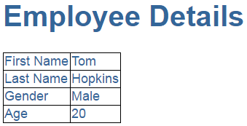

**As you can see from the image below we want to create 2 components**

* **AppComponent** - This component is the root component and displays just the page header
* **EmployeeComponent** - This component is the child component and displays the Employee details table. This child component will be nested inside the root AppComponent

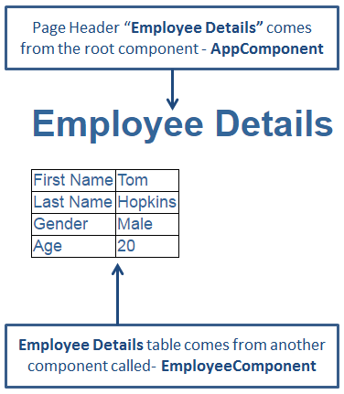   
  
**Step 1 :** Right click on the "App" folder and add a new folder. Name it "employee". We will create our EmployeeComponent in this folder.  
  
**Step 2 :** Right click on the "employee" folder and add a new HTML page. Name it employee.component.html. Copy and paste the following HTML.

<table>

    <tr>

        <td>First Name</td>

        <td>**{{**firstName**}}**</td>

    </tr>

    <tr>

        <td>Last Name</td>

        <td>**{{**lastName**}}**</td>

    </tr>

    <tr>

        <td>Gender</td>

        <td>**{{**gender**}}**</td>

    </tr>

    <tr>

        <td>Age</td>

        <td>**{{**age**}}**</td>

    </tr>

</table>

**Step 3 :** Right click on the **"employee"** folder and add a new TypeScript file. Name it employee.component.ts. Copy and paste the following code in it. At this point we have our child component EmployeeComponent created. Next let's create the root component - AppComponent.

import { Component } from '@angular/core';

@Component({

    selector: 'my-employee',

    templateUrl: 'app/employee/employee.component.html'

})

export class EmployeeComponent {

    firstName: string = 'Tom';

    lastName: string = 'Hopkins';

    gender: string = 'Male';

    age: number = 20;

}

**Step 4 :** We are going to use the root component to just display the page header. So in "app.component.ts" file, include the following code. Notice, since the View Template HTML is just 3 lines we have used an inline template instead of an external template. Angular2 recommends to extract templates into a separate file, if the view template is longer than 3 lines.

import { Component } from '@angular/core';

@Component({

    selector: 'my-app',

    template: `<div>

                    <h1>{{pageHeader}}</h1>

               </div>`

})

export class AppComponent {

    pageHeader: string = 'Employee Details';

}

At this point if we run the application, we only see the page header - "Employee Details", but not the table which has the employee details. To be able to display employee details table along with the page header, we will have to nest EmployeeComponent inside AppComponent. There are 2 simple steps to achieve this.  
  
**Step 1 :** In "app.module.ts" file we need to do 2 things as shown below.

* Import EmployeeComponent
* Add EmployeeComponent to the declarations array

import { NgModule } from '@angular/core';

import { BrowserModule } from '@angular/platform-browser';

import { AppComponent } from './app.component';

import { EmployeeComponent } from './employee/employee.component';

@NgModule({

    imports: [BrowserModule],

    declarations: [AppComponent, EmployeeComponent],

    bootstrap: [AppComponent]

})

export class AppModule { }

**What is AppModule**  
AppModule is the root module which bootstraps and launches the angular application. You can name it anything you want, but by convention it is named AppModule.  
  
**It imports 2 system modules - BrowserModule and NgModule**

* BrowserModule - Every application that runs in a browser needs this module. In a later video in this course we will discuss NgIf and NgFor directives which are also provided by this module.
* NgModule - @component decorator adds metadata to an angular component class, similarly @NgModule decorator adds metadata to the angular module class.

In [Part 4](https://www.youtube.com/watch?v=Nh6QJ7WrEyM) of this [tutorial](https://www.youtube.com/playlist?list=PL6n9fhu94yhWqGD8BuKuX-VTKqlNBj-m6), we discussed that if a class is decorated @component decorator then that class becomes an angular component. Similarly if a a class is decorated with @NgModule decorator then that class becomes an angular module.  
  
**Properties of the @NgModule decorator**

* imports - Imports the BrowserModule required for an angular application to run in a web browser
* declarations - Contains the components registered with this module. In our case we have two - AppComponent and EmployeeComponent
* bootstrap - Contains the root component that Angular creates and inserts into the index.html host web page

**Step 2 :** In "app.component.ts" file include "my-employee" as a directive. Remember in "employee.component.ts" file we used "my-employee" as a selector.

import { Component } from '@angular/core';

@Component({

    selector: 'my-app',

    template: `<div>

                    <h1>{{pageHeader}}</h1>

                    <my-employee></my-employee>

                </div>`

})

export class AppComponent {

    pageHeader: string = 'Employee Details';

}

Run the application and you will see both page header and the employee details table. The employee details table is not styled very well. To style the table, include the following styles for <td> and <table> elements in styles.css file.

table {

    color: #369;

    font-family: Arial, Helvetica, sans-serif;

    font-size:large;

    border-collapse: collapse;

}

td {

    border: 1px solid black;

}

Run the application and you will now see the employee details table with the specified styles applied. At this point, launch browser developers tools and click on the "Elements" tab and notice <my-app> and <my-employee> directives in the rendered HTML.   
  
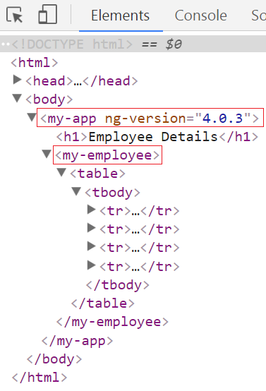

### Styling angular 2 components

**Suggested Videos**  
[Part 4 - Angular 2 components](https://www.youtube.com/watch?v=Nh6QJ7WrEyM) | [Text](http://csharp-video-tutorials.blogspot.com/2017/05/angular-2-components.html) | [Slides](http://csharp-video-tutorials.blogspot.com/2017/05/angular-2-components_30.html)  
[Part 5 - Angular template vs templateurl](https://www.youtube.com/watch?v=pX9fCcqbCl0) | [Text](http://csharp-video-tutorials.blogspot.com/2017/06/angular-template-vs-templateurl.html) | [Slides](http://csharp-video-tutorials.blogspot.com/2017/06/angular-template-vs-templateurl_6.html)  
[Part 6 - Angular 2 nested components](https://www.youtube.com/watch?v=BPLjY-9k-zE) | [Text](http://csharp-video-tutorials.blogspot.com/2017/06/angular-2-nested-components.html) | [Slides](http://csharp-video-tutorials.blogspot.com/2017/06/angular-2-nested-components_7.html)  
  
In this video we will discuss the different options available to apply styles to Angular Components. This is continuation to [Part 6](https://www.youtube.com/watch?v=BPLjY-9k-zE). Please watch [Part 6](https://www.youtube.com/watch?v=BPLjY-9k-zE) from [Angular 2 tutorial](https://www.youtube.com/playlist?list=PL6n9fhu94yhWqGD8BuKuX-VTKqlNBj-m6)before proceeding.

In our previous video we have built "employee" component which displays employee details in a table as shown below.   
  
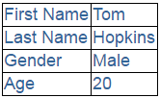

**employee.component.ts** 

import { Component } from '@angular/core';

@Component({

    selector: 'my-employee',

    templateUrl: 'app/employee/employee.component.html'

})

export class EmployeeComponent {

    firstName: string = 'Tom';

    lastName: string = 'Hopkins';

    gender: string = 'Male';

    age: number = 20;

}

**employee.component.html** 

<table>

    <tr>

        <td>First Name</td>

        <td>**{{**firstName**}}**</td>

    </tr>

    <tr>

        <td>Last Name</td>

        <td>**{{**lastName**}}**</td>

    </tr>

    <tr>

        <td>Gender</td>

        <td>**{{**gender**}}**</td>

    </tr>

    <tr>

        <td>Age</td>

        <td>**{{**age**}}**</td>

    </tr>

</table>

The following are the different options available to style this **"employee component"**  
  
**Option 1:**Specify the following <table> and <td> styles in external stylesheet - **styles.css** 

table {

    color: #369;

    font-family: Arial, Helvetica, sans-serif;

    font-size: large;

    border-collapse: collapse;

}

td {

    border: 1px solid black;

}

**Advantages :**

1. Visual Studio editor features (Intellisense, Code completion & formatting) are available.
2. Application maintenance is also easy as we only have to change the styles in one place if we need to change them for any reason.

**Disadvantages :**

1. The Stylesheet that contains the styles must be referenced for the component to be reused.
2. Since styles.css is referenced in index.html page, these styles may affect the table and td elements in other components, and you may or may not want this behaviour.

**Option 2 :**Specify the styles inline in the component HTML file as shown below. 

<table style="color: #369;font-family: Arial, Helvetica, sans-serif;

              font-size:large;border-collapse: collapse;">

    <tr>

        <td style="border: 1px solid black;">First Name</td>

        <td style="border: 1px solid black;">**{{**firstName**}}**</td>

    </tr>

    <tr>

        <td style="border: 1px solid black;">Last Name</td>

        <td style="border: 1px solid black;">**{{**lastName**}}**</td>

    </tr>

    <tr>

        <td style="border: 1px solid black;">Gender</td>

        <td style="border: 1px solid black;">**{{**gender**}}**</td>

    </tr>

    <tr>

        <td style="border: 1px solid black;">Age</td>

        <td style="border: 1px solid black;">**{{**age**}}**</td>

    </tr>

</table>

**Advantages :**

1. Visual Studio editor features (Intellisense, Code completion & formatting) are available.
2. Component can be easily reused as the styles are defined inline
3. Styles specified using this approach are local to the component and don't collide with styles used elsewhere in the application.

**Disadvantages :**

1. Application maintenance is difficult. For example, if we want to change the <td> border colour to red we have to change it in several places.

**Option 3 :** Specify the styles in the component html file using <style> tag as shown below 

<style>

    table {

        color: #369;

        font-family: Arial, Helvetica, sans-serif;

        font-size: large;

        border-collapse: collapse;

    }

    td {

        border: 1px solid black;

    }

</style>

<table>

    <tr>

        <td>First Name</td>

        <td>**{{**firstName**}}**</td>

    </tr>

    <tr>

        <td>Last Name</td>

        <td>**{{**lastName**}}**</td>

    </tr>

    <tr>

        <td>Gender</td>

        <td>**{{**gender**}}**</td>

    </tr>

    <tr>

        <td>Age</td>

        <td>**{{**age**}}**</td>

    </tr>

</table>

**Advantages :**

1. Component can be easily reused as the styles are defined inline with in the component itself
2. Application maintenance is also easy as we only have to change the styles in one place
3. Visual Studio editor features (Intellisense, Code completion & formatting) are available
4. Styles specified using this approach are local to the component and don't collide with styles used elsewhere in the application.

**Option 4 :** Specify the styles in the component TypeScript file using the @component decorator styles property as shown below. Notice the styles property takes an array of strings containing your styles. 

import { Component } from '@angular/core';

@Component({

    selector: 'my-employee',

    templateUrl: 'app/employee/employee.component.html',

    styles: ['table { color: #369; font-family: Arial, Helvetica, sans-serif; font-size: large; border-collapse: collapse;}', 'td {border: 1px solid black; }']

})

export class EmployeeComponent {

    firstName: string = 'Tom';

    lastName: string = 'Hopkins';

    gender: string = 'Male';

    age: number = 20;

}

**Advantages :**

1. Component can be easily reused as the styles are defined inline with in the component itself
2. Application maintenance is also easy as we only have to change the styles in one place for this component if we need to change them for any reason.
3. Styles specified using this approach are local to the component and don't collide with styles used elsewhere in the application.

**Disadvantages :**

1. Visual Studio editor features (Intellisense, Code completion & formatting) are not available.

**Option 5 :**Specify the styles using the @component decorator styleUrls property. The styleUrls property is an array of strings containing stylesheet URLs.   
  
**Step 1 :**Right click on the "employee" folder and add a new StyleSheet. Name it employee.component.css  
  
**Step 2 :**Copy and paste the following styles for <table> and <td> elements in employee.component.css

table {

    color: #369;

    font-family: Arial, Helvetica, sans-serif;

    font-size: large;

    border-collapse: collapse;

}

td {

    border: 1px solid black;

}

**Step 3 :** In employee.component.ts file reference employee.component.css stylesheet using styleUrls property as shown below. Please note, the stylesheet path is relative to index.html file.

import { Component } from '@angular/core';

@Component({

    selector: 'my-employee',

    templateUrl: 'app/employee/employee.component.html',

    styleUrls: ['app/employee/employee.component.css']

})

export class EmployeeComponent {

    firstName: string = 'Tom';

    lastName: string = 'Hopkins';

    gender: string = 'Male';

    age: number = 20;

}

**Advantages :**

1. Component can be easily reused as both the stylesheet itself and it's path are included with in the component
2. Application maintenance is also easy as we only have to change the styles in one place
3. Visual Studio editor features (Intellisense, Code completion & formatting) are available
4. Styles specified using this approach are local to the component and don't collide with styles used elsewhere in the application.

### Angular interpolation

**Suggested Videos**  
[Part 5 - Angular template vs templateurl](https://www.youtube.com/watch?v=pX9fCcqbCl0) | [Text](http://csharp-video-tutorials.blogspot.com/2017/06/angular-template-vs-templateurl.html) | [Slides](http://csharp-video-tutorials.blogspot.com/2017/06/angular-template-vs-templateurl_6.html)  
[Part 6 - Angular 2 nested components](https://www.youtube.com/watch?v=BPLjY-9k-zE) | [Text](http://csharp-video-tutorials.blogspot.com/2017/06/angular-2-nested-components.html) | [Slides](http://csharp-video-tutorials.blogspot.com/2017/06/angular-2-nested-components_7.html)   
[Part 7 - Styling angular 2 components](https://www.youtube.com/watch?v=vB5ihfGp1-I) | [Text](http://csharp-video-tutorials.blogspot.com/2017/06/styling-angular-2-components.html) | [Slides](http://csharp-video-tutorials.blogspot.com/2017/06/styling-angular-2-components_13.html)  
  
In this video we will discuss the concept of Interpolation in Angular.   
  
Interpolation is all about data binding. In Angular data-binding can be broadly classified into 3 categories

|  |  |
| --- | --- |
| **Data Binding** | **Description** |
| One way data-binding | From Component to View Template |
| One way data-binding | From View Template to Component |
| Two way data-binding | From Component to View Template & From View template to Component |

In this video, we will discuss the first one way data-binding i.e From Component to View Template. We achieve this using interpolation. We will discuss the rest of the 2 data-binding techniques in our upcoming videos.  
  
**One way data-binding** - From Component to View Template : To display read-only data on a view template we use one-way data binding technique interpolation. With interpolation, we place the component property name in the view template, enclosed in double curly braces: {{propertyName}}.

In the following example, Angular pulls the value of the firstName property from the component and inserts it between the opening and closing <h1> element.

import { Component } from '@angular/core';

@Component({

    selector: 'my-app',

    template: `

                <h1>{{ firstName }}</h1>

              `

})

export class AppComponent {

    firstName: string = 'Tom';

}

**Output :**   
angular interpolation example   
  
It is also possible to concatenate a hard-coded string with the property value

<h1>{{'Name = ' + firstName}}</h1>

The above expression displayes **"Name = Tom"** in the browser.  
  
You can specify any valid expression in double curly braces. For example you can have

<h1>{{ 10 + 20 + 30 }}</h1>

The above expression evaluates to 60  
  
The expression that is enclosed in double curly braces is commonly called as Template Expression. This template expression can also be a ternary operator as shown in the example below. Since firstName property has a value 'Tom', we see it in the browser.

import { Component } from '@angular/core';

@Component({

    selector: 'my-app',

    template: `

                <h1>{{firstName ? firstName : 'No name specified'}}</h1>

              `

})

export class AppComponent {

    firstName: string = 'Tom';

}

If we set firstName = null as shown below. The value **'No name specified'** is displayed in the browser  
firstName: string = null;  
  
You can also use interpolation to set <img> src as shown in the example below.

import { Component } from '@angular/core';

@Component({

    selector: 'my-app',

    template: `<div>

                    <h1>{{pageHeader}}</h1>

                    <img src='{{imagePath}}'/>

                </div>`

})

export class AppComponent {

    pageHeader: string = 'Employee Details';

    imagePath: string = 'http://pragimtech.com/images/logo.jpg';

}

**Output :**   
   
  
We can also call class methods using interpolation as shown below.

import { Component } from '@angular/core';

@Component({

    selector: 'my-app',

    template: `<div>

                    <h1>{{'Full Name = ' + getFullName()}}</h1>

                </div>`

})

export class AppComponent {

    firstName: string = 'Tom';

    lastName: string = 'Hopkins';

    getFullName(): string {

        return this.firstName + ' ' + this.lastName;

    }

}

**Output :** Full Name = Tom Hopkins

### Property binding in Angular 2

**Suggested Videos**  
[Part 6 - Angular 2 nested components](https://www.youtube.com/watch?v=BPLjY-9k-zE) | [Text](http://csharp-video-tutorials.blogspot.com/2017/06/angular-2-nested-components.html) | [Slides](http://csharp-video-tutorials.blogspot.com/2017/06/angular-2-nested-components_7.html)  
[Part 7 - Styling angular 2 components](https://www.youtube.com/watch?v=vB5ihfGp1-I) | [Text](http://csharp-video-tutorials.blogspot.com/2017/06/styling-angular-2-components.html) | [Slides](http://csharp-video-tutorials.blogspot.com/2017/06/styling-angular-2-components_13.html)   
[Part 8 - Angular interpolation](https://www.youtube.com/watch?v=2FkkAqFWRk8) | [Text](http://csharp-video-tutorials.blogspot.com/2017/06/angular-interpolation.html) | [Slides](http://csharp-video-tutorials.blogspot.com/2017/06/angular-interpolation_14.html)  
  
In this video we will discuss **Property binding in Angular** with examples.    
  
In [Part 8](https://www.youtube.com/watch?v=2FkkAqFWRk8), we discussed we can use interpolation to bind component class properties to view template. Another option to achieve exactly the same thing is by using **Property binding**.

In our previous video we have bound imagePath property of the component class to <img> element src property using interpolation as shown below.  
<img src='{{imagePath}}'/>   
  
We can rerwrite the above example, using property binding as shown below. Notice the <img> element src property is in a pair of square brackets, and the component class property is in quotes.  
<img [src]='imagePath'/>

Both **Interpolation**and **Property binding**flows a value in one direction, i.e from a component's data property into a target element property.  
  
**What is the difference between Interpolation and Property binding**  
Interpolation is a special syntax that Angular converts into a property binding.   
  
Interpolation is just a convenient alternative to property binding.   
  
In some cases like when we need to concatenate strings we have to use interpolation instead of property binding as shown in the example below.  
<img src='http://www.pragimtech.com/{{imagePath}}' />  
  
When setting an element property to a non-string data value, you must use property binding. In the following example, we are disabling a button by binding to the boolean property isDisabled.  
<button [disabled]='isDisabled'>Click me</button>  
  
If we use interpolation instead of property binding, the button is always disabled irrespective of isDisabled class property value  
<button disabled='{{isDisabled}}'>Click me</button>  
  
**Some important points to keep in mind when using Property binding**  
  
Remember to enclose the property name with a pair of square brackets. If you omit the brackets, Angular treats the string as a constant and initializes the target property with that string.  
<span [innerHTML]='pageHeader'></span>  
  
With Property binding we enclose the element property name in square brackets  
<button [disabled]='isDisabled'>Click me</button>  
  
We can also use the alternate syntax with bind- prefix. This is known as canonical form  
<button bind-disabled='isDisabled'>Click me</button>  
  
From security standpoint, Angular data binding sanitizes malicious content before displaying it on the browser. Both interpolation and property binding protects us from malicious content.   
  
In the example below we are using interpolation. Notice the malicious usage of <script> tag.

import { Component } from '@angular/core';

@Component({

    selector: 'my-app',

    template: '<div>{{badHtml}}</div>'

})

export class AppComponent {

    badHtml: string = 'Hello <script>alert("Hacked");</script> World';

}

Angular interpolation sanitizes the malicious content and displays the following in the browser  
Hello <script>alert("Hacked");</script> World  
  
In this example below we are using property binding.   
'<div [innerHtml]="badHtml"></div>'  
  
Property binding sanitizes the malicious content slightly differently and we get the following output, but the important point to keep in mind is both the techniques protect us from malicious content and render the content harmlessly.  
Hello alert("Hacked"); World

### html attribute vs dom property

**Suggested Videos**  
[Part 7 - Styling angular 2 components](https://www.youtube.com/watch?v=vB5ihfGp1-I) | [Text](http://csharp-video-tutorials.blogspot.com/2017/06/styling-angular-2-components.html) | [Slides](http://csharp-video-tutorials.blogspot.com/2017/06/styling-angular-2-components_13.html)  
[Part 8 - Angular interpolation](https://www.youtube.com/watch?v=2FkkAqFWRk8) | [Text](http://csharp-video-tutorials.blogspot.com/2017/06/angular-interpolation.html) | [Slides](http://csharp-video-tutorials.blogspot.com/2017/06/angular-interpolation_14.html)   
[Part 9 - Property binding in Angular 2](https://www.youtube.com/watch?v=RGYfTx9AAQA) | [Text](http://csharp-video-tutorials.blogspot.com/2017/06/property-binding-in-angular-2.html) | [Slides](http://csharp-video-tutorials.blogspot.com/2017/06/property-binding-in-angular-2_19.html)  
  
In this video we will discuss the **difference between HTML attribute and DOM property**.

**What is DOM**  
DOM stands for Document Object Model. When a browser loads a web page, the browser creates a Document Object Model of that page.

For example, for the HTML below,   
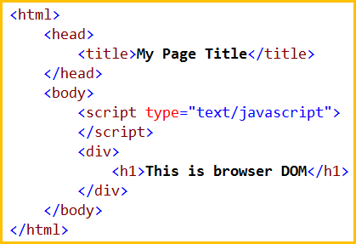   
  
The browser creates a Document Object Model of that page as shown below   
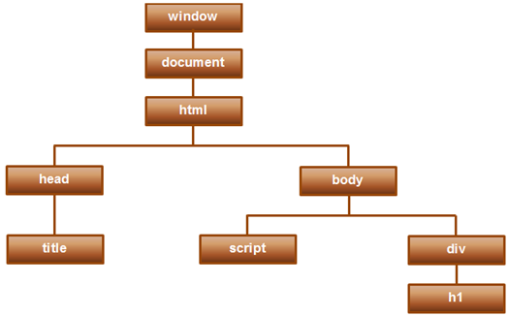   
  
So in simple terms you can think of the DOM as an application programming interface (API) for HTML, and we can use programming languages like JavaScript, or JavaScript frameworks like Angular to access and manipulate the HTML using their corresponding DOM objects.   
  
In other words DOM contains the HTML elements as objects, their properties, methods and events and it is a standard for accessing, modifying, adding or deleting HTML elements.  
  
In the previous 2 videos we discussed interpolation and property binding in Angular.  
  
**Interpolation example**  
<button disabled='{{isDisabled}}'>Click Me</button>  
  
**Property binding example**  
<button [disabled]='isDisabled'>Click Me</button>  
  
If you notice the above 2 examples, it looks like we are binding to the Button's disabled attribute. This is not true. We are actually binding to the disabled property of the button object. Angular data-binding is all about binding to DOM object properties and not HTML element attributes.  
  
**What is the difference between HTML element attribute and DOM property**

1. Attributes are defined by HTML, where as properties are defined by the DOM.
2. Attributes initialize DOM properties. Once the initialization complete, the attributes job is done.
3. Property values can change, where as attribute values can't.

Let's prove this point - Property values change, but the attribute values don't with an example.  
  
In the example below, we have set the value attribute of the input element to Tom.  
<input id='inputId' type='text' value='Tom'>  
  
At this point, run the web page and in the textbox you will see 'Tom' as the value.   
  
Launch the browser developer tools.  
  
On the 'Console' tab, use the getattribute() method and value property of the input element to get the attribute and property values. Notice at the moment both have the value 'Tom'   
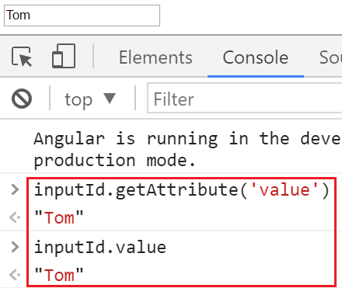   
  
Change the value in the textbox to Mary.  
  
Notice now, when we query for the attribute and property values, the attribute value is still Tom but the property value is Mary. So this proves the point - Property values change, where as attribute values don't.   
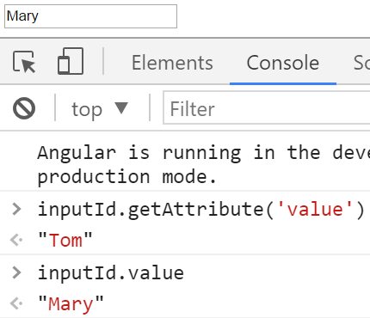   
  
**So it is important to keep in mind that,**

1. HTML attributes and the DOM properties are different things.
2. Angular binding works with properties and events, and not attributes.
3. The role of attributes is to initialize element properties and their job is done

### Angular attribute binding

**Suggested Videos**  
[Part 8 - Angular interpolation](https://www.youtube.com/watch?v=2FkkAqFWRk8) | [Text](http://csharp-video-tutorials.blogspot.com/2017/06/angular-interpolation.html) | [Slides](http://csharp-video-tutorials.blogspot.com/2017/06/angular-interpolation_14.html)  
[Part 9 - Property binding in Angular 2](https://www.youtube.com/watch?v=RGYfTx9AAQA) | [Text](http://csharp-video-tutorials.blogspot.com/2017/06/property-binding-in-angular-2.html) | [Slides](http://csharp-video-tutorials.blogspot.com/2017/06/property-binding-in-angular-2_19.html)   
[Part 10 - html attribute vs dom property](https://www.youtube.com/watch?v=Ut-ATm23_Pg) | [Text](http://csharp-video-tutorials.blogspot.com/2017/06/html-attribute-vs-dom-property.html) | [Slides](http://csharp-video-tutorials.blogspot.com/2017/06/html-attribute-vs-dom-property_20.html)  
  
In this video we will discuss **Attribute Binding in Angular**  
  
In our previous videos we discussed **Interpolation**and  **Property binding**that deal with binding Component class properties to HTML element properties and not Attributes.

However, in some situations we want to be able to bind to HTML element attributes. For example, **colspan**and **aria**attributes does not have corresponding DOM properties. So in this case we want to be able to bind to HTML element attributes.   
  
To make  this happen, Angular provides attribute binding. With **attribute binding** we can set the value of an attribute directly. Angular team recommends to use Property binding when possible and use attribute binding only when there is no corresponding element property to bind.

Let us understand **Attribute Binding in Angular**with an example. We want to display Employee Details in a table as shown below.   
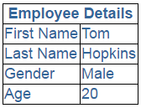   
  
To achieve this we are going to make use of Employee component we have implemented in [Part 6](https://www.youtube.com/watch?v=BPLjY-9k-zE) of [Angular 2 tutorial](https://www.youtube.com/playlist?list=PL6n9fhu94yhWqGD8BuKuX-VTKqlNBj-m6).  
  
In our root component - **app.component.ts** we have the following code

import { Component } from '@angular/core';

@Component({

    selector: 'my-app',

    template: `

                <div>

                    <my-employee></my-employee>

                </div>

             `

})

export class AppComponent {

}

**Code in employee.component.ts file**

import { Component } from '@angular/core';

@Component({

    selector: 'my-employee',

    templateUrl: 'app/employee/employee.component.html',

    styleUrls: ['app/employee/employee.component.css']

})

export class EmployeeComponent {

    imagePath: string = 'Tom.png';

    firstName: string = 'Tom';

    lastName: string = 'Hopkins';

    gender: string = 'Male';

    age: number = 20;

}

**Code in employee.component.css file**

table {

    color: #369;

    font-family: Arial, Helvetica, sans-serif;

    font-size: large;

    border-collapse: collapse;

}

td {

    border: 1px solid black;

}

thead{

    border: 1px solid black;

}

**Code in employee.component.html file**

<table>

    <thead>

        <tr>

            <th colspan="2">

                Employee Details

            </th>

        </tr>

    </thead>

    <tbody>

        <tr>

            <td>First Name</td>

            <td>{{firstName}}</td>

        </tr>

        <tr>

            <td>Last Name</td>

            <td>{{lastName}}</td>

        </tr>

        <tr>

            <td>Gender</td>

            <td>{{gender}}</td>

        </tr>

        <tr>

            <td>Age</td>

            <td>{{age}}</td>

        </tr>

    </tbody>

</table>

Notice at the moment we have hard-coded **colspan**attribute value to 2 in the HTML. Instead we want to bind to a component class property. So in the employee.component.ts file include 'columnSpan' property as shown below.

export class EmployeeComponent {

    columnSpan: number = 2;

    imagePath: string = 'Tom.png';

    firstName: string = 'Tom';

    lastName: string = 'Hopkins';

    gender: string = 'Male';

    age: number = 20;

}

If we use interpolation to bind columnSpan property of the component class to colspan attribute of the <th> element we get the error - Can't bind to 'colspan' since it isn't a known property of 'th'

<th colspan="{{columnSpan}}">

We get the same error if we use Property Binding

<th [colspan]="columnSpan">

This error is because we do not have a corresponding property in the DOM for colspan attribute. To fix this we have to use attribute-binding in Angular, which sets the colspan attribute. To tell angular framework that we are setting an attribute value we have to prefix the attribute name with attr and a DOT as shown below.

<th [attr.colspan]="columnSpan">

The same is true when using interpolation

<th attr.colspan="{{columnSpan}}">

### Class binding in angular 2

**Suggested Videos**  
[Part 9 - Property binding in Angular 2](https://www.youtube.com/watch?v=RGYfTx9AAQA) | [Text](http://csharp-video-tutorials.blogspot.com/2017/06/property-binding-in-angular-2.html) | [Slides](http://csharp-video-tutorials.blogspot.com/2017/06/property-binding-in-angular-2_19.html)  
[Part 10 - html attribute vs dom property](https://www.youtube.com/watch?v=Ut-ATm23_Pg) | [Text](http://csharp-video-tutorials.blogspot.com/2017/06/html-attribute-vs-dom-property.html) | [Slides](http://csharp-video-tutorials.blogspot.com/2017/06/html-attribute-vs-dom-property_20.html)   
[Part 11 - Angular attribute binding](https://www.youtube.com/watch?v=OZJiQ5kj9us) | [Text](http://csharp-video-tutorials.blogspot.com/2017/06/angular-attribute-binding.html) | [Slides](http://csharp-video-tutorials.blogspot.com/2017/06/angular-attribute-binding_27.html)  
  
In this video we will discuss **CSS Class binding in Angular** with examples.  
  
For the demos in this video, we will use same example we have been working with so far in this video series. In **styles.css** file include the following 3 CSS classes. If you recollect styles.css is already referenced in our host page - index.html.

.boldClass{

    font-weight:bold;

}

.italicsClass{

    font-style:italic;

}

.colorClass{

    color:red;

}

In **app.component.ts**, include a button element as shown below. Notice we have set the class attribute of the button element to 'colorClass'. 

import { Component } from '@angular/core';

@Component({

    selector: 'my-app',

    template: `

                <button class='colorClass'>My Button</button>

              `

})

export class AppComponent {

}

At this point, run the application and notice that the 'colorClass' is added to the button element as expected.  
  
Replace all the existing css classes with one or more classes  
  
**Modify the code in app.component.ts as shown below.**

1. We have introduced a property 'classesToApply' in **AppComponent**class
2. We have also specified class binding for the button element. The word 'class' is in a pair of square brackets and it is binded to the property 'classesToApply'
3. This will replace the existing css classes of the button with classes specified in the class binding

import { Component } from '@angular/core';

@Component({

    selector: 'my-app',

    template: `

                <button class='colorClass' [class]='classesToApply'>My Button</button>

              `

})

export class AppComponent {

    classesToApply: string = 'italicsClass boldClass';

}

Run the application and notice 'colorClass' is removed and these classes (italicsClass & boldClass) are added.  
  
Adding or removing a single class : To add or remove a single class, include the prefix 'class' in a pair of square brackets, followed by a DOT and then the name of the class that you want to add or remove. The following example adds boldClass to the button element. Notice it does not remove the existing colorClass already added using the class attribute. If you change applyBoldClass property to false or remove the property altogether from the AppComponent class, css class boldClass is not added to the button element.

import { Component } from '@angular/core';

@Component({

    selector: 'my-app',

    template: `

                <button class='colorClass' [class.boldClass]='applyBoldClass'>My Button</button>

              `

})

export class AppComponent {

    applyBoldClass: boolean = true;

}

With class binding we can also use ! symbol. Notice in the example below applyBoldClass is set to false. Since we have used ! in the class binding the class is added as expected.

import { Component } from '@angular/core';

@Component({

    selector: 'my-app',

    template: `

                <button class='colorClass' [class.boldClass]='!applyBoldClass'>My Button</button>

              `

})

export class AppComponent {

    applyBoldClass: boolean = false;

}

You can also removed an existing class that is already applied. Consider the following example. Notice we have 3 classes (colorClass, boldClass & italicsClass) added to the button element using the class attribute. The class binding removes the boldClass.

import { Component } from '@angular/core';

@Component({

    selector: 'my-app',

    template: `

                <button class='colorClass boldClass italicsClass'

                        [class.boldClass]='applyBoldClass'>My Button</button>

              `

})

export class AppComponent {

    applyBoldClass: boolean = false;

}

**To add or remove multiple classes use ngClass directive as shown in the example below.**

1. Notice the colorClass is added using the class attribute
2. ngClass is binded to addClasses() method of the AppComponent class
3. addClasses() method returns an object with 2 key/value pairs. The key is a CSS class name. The value can be true or false. True to add the class and false to remove the class.
4. Since both the keys (boldClass & italicsClass) are set to true, both classes will be added to the button element
5. let is a new type of variable declaration in JavaScript.
6. let is similar to var in some respects but allows us to avoid some of the common gotchas that we run into when using var.
7. The differences between let and var are beyond the scope of this video. For our example, var also works fine.
8. As TypeScript is a superset of JavaScript, it supports let

import { Component } from '@angular/core';

@Component({

    selector: 'my-app',

    template: `

                <button class='colorClass' [ngClass]='addClasses()'>My Button</button>

             `

})

export class AppComponent {

    applyBoldClass: boolean = true;

    applyItalicsClass: boolean = true;

    addClasses() {

        let classes = {

            boldClass: this.applyBoldClass,

            italicsClass: this.applyItalicsClass

        };

        return classes;

    }

}

We have included our css classes in a external stylesheet - **styles.css**. Please note we can also include these classes in the styles property instead of a separate stylesheet as shown below.

import { Component } from '@angular/core';

@Component({

    selector: 'my-app',

    template: `

                <button class='colorClass' [ngClass]='addClasses()'>My Button</button>

             `,

    styles: [`

            .boldClass{

                font-weight:bold;

            }

            .italicsClass{

                font-style:italic;

            }

            .colorClass{

                color:red;

            }

             `]

})

export class AppComponent {

    applyBoldClass: boolean = true;

    applyItalicsClass: boolean = true;

    addClasses() {

        let classes = {

            boldClass: this.applyBoldClass,

            italicsClass: this.applyItalicsClass

        };

        return classes;

    }

}

### Style binding in angular 2

**Suggested Videos**  
[Part 10 - html attribute vs dom property](https://www.youtube.com/watch?v=Ut-ATm23_Pg) | [Text](http://csharp-video-tutorials.blogspot.com/2017/06/html-attribute-vs-dom-property.html) | [Slides](http://csharp-video-tutorials.blogspot.com/2017/06/html-attribute-vs-dom-property_20.html)  
[Part 11 - Angular attribute binding](https://www.youtube.com/watch?v=OZJiQ5kj9us) | [Text](http://csharp-video-tutorials.blogspot.com/2017/06/angular-attribute-binding.html) | [Slides](http://csharp-video-tutorials.blogspot.com/2017/06/angular-attribute-binding_27.html)   
[Part 12 - Class binding in angular 2](https://www.youtube.com/watch?v=Ea_6MIIVK0Y) | [Text](http://csharp-video-tutorials.blogspot.com/2017/06/class-binding-in-angular-2.html) | [Slides](http://csharp-video-tutorials.blogspot.com/2017/06/class-binding-in-angular-2_28.html)  
  
In this video we will discuss **Style binding in Angular** with examples.   
  
Setting inline styles with style binding is very similar to setting CSS classes with class binding. Please watch [Class binding video](https://www.youtube.com/watch?v=Ea_6MIIVK0Y) from [Angular 2 tutorial](https://www.youtube.com/playlist?list=PL6n9fhu94yhWqGD8BuKuX-VTKqlNBj-m6) before proceeding with this video.

Notice in the example below, we have set the font color of the button using the style attribute. 

import { Component } from '@angular/core';

@Component({

    selector: 'my-app',

    template: `

                <button style="color:red">My Button</button>

              `

})

export class AppComponent {

}

The following example sets a single style (font-weight). If the property **'isBold'** is true, then font-weight style is set to bold else normal. 

import { Component } from '@angular/core';

@Component({

    selector: 'my-app',

    template: `

                <button style='color:red'

                        [style.font-weight]="isBold ? 'bold' : 'normal'">My Button

                </button>

              `

})

export class AppComponent {

    isBold: boolean = true;

}

**style property name**can be written in either dash-case or camelCase. For example, font-weight style can also be written using camel case - fontWeight.   
  
Some styles like font-size have a unit extension. To set font-size in pixels use the following syntax. This example sets font-size to 30 pixels. 

import { Component } from '@angular/core';

@Component({

    selector: 'my-app',

    template: `

                <button style='color:red'

                        [style.font-size.px]="fontSize">My Button

                </button>

              `

})

export class AppComponent {

    fontSize: number = 30;

}

**To set multiple inline styles use NgStyle directive as shown below**

* Notice the color style is added using the style attribute
* ngStyle is binded to **addStyles()** method of the AppComponent class
* **addStyles()** method returns an object with 2 key/value pairs. The key is a style name, and the value is a value for the respective style property or an expression that returns the style value.
* let is a new type of variable declaration in JavaScript.
* let is similar to var in some respects but allows us to avoid some of the common gotchas that we run into when using var.
* The differences between let and var are beyond the scope of this video. For our example, var also works fine.
* As TypeScript is a superset of JavaScript, it supports let

import { Component } from '@angular/core';

@Component({

    selector: 'my-app',

    template: ` <button style='color:red' [ngStyle]="addStyles()">My Button</button>

                    `

})

export class AppComponent {

    isBold: boolean = true;

    fontSize: number = 30;

    isItalic: boolean = true;

    addStyles() {

        let styles = {

            'font-weight': this.isBold ? 'bold' : 'normal',

            'font-style': this.isItalic ? 'italic' : 'normal',

            'font-size.px': this.fontSize

        };

        return styles;

    }

}

### Angular2 event binding

**Suggested Videos**  
[Part 11 - Angular attribute binding](https://www.youtube.com/watch?v=OZJiQ5kj9us) | [Text](http://csharp-video-tutorials.blogspot.com/2017/06/angular-attribute-binding.html) | [Slides](http://csharp-video-tutorials.blogspot.com/2017/06/angular-attribute-binding_27.html)  
[Part 12 - Class binding in angular 2](https://www.youtube.com/watch?v=Ea_6MIIVK0Y) | [Text](http://csharp-video-tutorials.blogspot.com/2017/06/class-binding-in-angular-2.html) | [Slides](http://csharp-video-tutorials.blogspot.com/2017/06/class-binding-in-angular-2_28.html)   
[Part 13 - Style binding in angular 2](https://www.youtube.com/watch?v=dIn7E1P5boE) | [Text](http://csharp-video-tutorials.blogspot.com/2017/06/style-binding-in-angular-2.html) | [Slides](http://csharp-video-tutorials.blogspot.com/2017/06/style-binding-in-angular-2_29.html)  
  
In this video we will discuss **Event Binding in Angular** with examples.

The following bindings that we have discussed so far in this video series flow data in one direction i.e from a component class property to an HTML element property.  
1. Interpolation  
2. Property Binding  
3. Attribute Binding  
4. Class Binding  
5. Style Binding

**How about flowing data in the opposite direction** i.e from an HTML element to a component. When a user performs any action like clicking on a button, hovering over an element, selecting from a dropdownlist, typing in a textbox etc, then the corresponding event for that action is raised. We need to know when user performs these actions. We can use angular event binding to get notified when these events occur.   
  
For example the following is the syntax for binding to the click event of a button. Within parentheses on the left of the equal sign we have the target event, (click) in this case and on the right we have the template statement. In this case the **onClick**() method of the component class is called when the click event occurs.

<button (click)="onClick()">Click me</button>

With event binding we can also use the on- prefix alternative as shown below. This is known as the canonical form

<button on-click="onClick()">Click me</button>

**Event Binding Example :** 

import { Component } from '@angular/core';

@Component({

    selector: 'my-app',

    template: `<button (click)='onClick()' >Click me</button>`

})

export class AppComponent {

    onClick(): void {

        console.log('Button Clicked');

    }

}

Every time we click the button, 'Button Clicked' message is logged to the console. You can see this message under the Console tab, in the browser developer tools.   
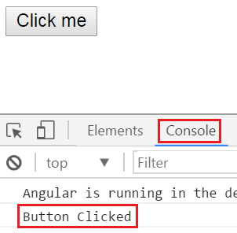   
  
**Another Example :** Initially when the page loads we want to display only the First Name and Last of Employee. We also want to display "Show Details" button.   
  
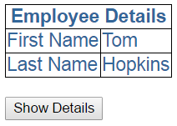   
  
When we click **"Show Details"** button, we want to display **"Gender"** and **"Age"** as well. The text on the button should be changed to **"Hide Details"**. When we click **"Hide Details"** button, **"Gender"** and **"Age"**should be hidden and the button text should be changed to **"Show Details"**.   
  
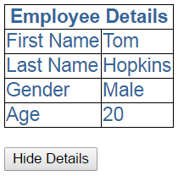   
  
To achieve this we will make use of event binding in Angular. We will also make use of one of the structural directives "ngIf" in angular.  
  
Code in **employee.component.ts** : Notice we have introduced "showDetails" boolean property. The default value is false, so when the page first loads, we will have "Gender" and "Age" hidden. We also have a method, toggleDetails(), which toggles the value of showDetails. 

import { Component } from '@angular/core';

@Component({

    selector: 'my-employee',

    templateUrl: 'app/employee/employee.component.html',

    styleUrls: ['app/employee/employee.component.css']

})

export class EmployeeComponent {

    columnSpan: number = 2;

    firstName: string = 'Tom';

    lastName: string = 'Hopkins';

    gender: string = 'Male';

    age: number = 20;

    showDetails: boolean = false;

    toggleDetails(): void {

        this.showDetails = !this.showDetails;

    }

}

Code in **employee.component.html** :

* Notice the click event of the button is binded to toggleDetails() method
* To dynamicall change the text on the button, we are using ternary operator - {{showDetails ? 'Hide' : 'Show'}} Details
* We used ngIf structural directive on "Gender" and "Age" <tr> elements
* The * prefix before a directive indicates, it is a structural directive
* Besides ngIf, there are other structural directives which we will discuss in our upcoming videos
* The ngIf directive conditionally adds or removes content from the DOM based on whether or not an expression is true or false
* If "showDetails" is true, "Gender" and "Age" <tr> elements are added to the DOM, else removed

<table>

    <thead>

        <tr>

            <th attr.colspan="**{{**columnSpan**}}**">

                Employee Details

            </th>

        </tr>

    </thead>

    <tbody>

        <tr>

            <td>First Name</td>

            <td>**{{**firstName**}}**</td>

        </tr>

        <tr>

            <td>Last Name</td>

            <td>**{{**lastName**}}**</td>

        </tr>

        <tr *ngIf='showDetails'>

            <td>Gender</td>

            <td>**{{**gender**}}**</td>

        </tr>

        <tr *ngIf='showDetails'>

            <td>Age</td>

            <td>**{{**age**}}**</td>

        </tr>

    </tbody>

</table>

<br />

<button (click)='toggleDetails()'>

**{{**showDetails ? 'Hide' : 'Show'**}}** Details

</button>

### Two way data binding in angular 2

**Suggested Videos**  
[Part 12 - Class binding in angular 2](https://www.youtube.com/watch?v=Ea_6MIIVK0Y) | [Text](http://csharp-video-tutorials.blogspot.com/2017/06/class-binding-in-angular-2.html) | [Slides](http://csharp-video-tutorials.blogspot.com/2017/06/class-binding-in-angular-2_28.html)  
[Part 13 - Style binding in angular 2](https://www.youtube.com/watch?v=dIn7E1P5boE) | [Text](http://csharp-video-tutorials.blogspot.com/2017/06/style-binding-in-angular-2.html) | [Slides](http://csharp-video-tutorials.blogspot.com/2017/06/style-binding-in-angular-2_29.html)   
[Part 14 - Angular2 event binding](https://www.youtube.com/watch?v=g8ofqqT_UAM) | [Text](http://csharp-video-tutorials.blogspot.com/2017/07/angular2-event-binding.html) | [Slides](http://csharp-video-tutorials.blogspot.com/2017/07/angular2-event-binding_4.html)  
  
In this video we will discuss **Two way Data Binding in Angular 2**.   
  
Consider the following code in **app.component.ts**

import { Component } from '@angular/core';

@Component({

    selector: 'my-app',

    template: `

                Name : <input [value]='name'>

                <br>

                You entered : {{name}}

              `

})

export class AppComponent {

    name: string = 'Tom';

}

* <input [value]='name'> : Binds component class "name" property to the input element’s value property
* You entered : {{name}} : Interpolation displays the value we have in "name" property on the web page

**Here is the output**   
Two way data binding in angular 2   
  
At the moment when we change the value in the textbox, that changed value is not reflected in the browser. One way to achieve this is by binding to the input event of the input control as shown below. 

Name : <input [value]='name' (input)='name = $event.target.value'>

<br>

You entered : **{{**name**}}**

At this point, as we type in the textbox, the changed value is displayed on the page.   
  
angular 2 2 way binding example   
  
So let's understand what is happening here. Conside this code  

Name : <input [value]='name' (input)='name = $event.target.value'>

<br>

You entered : {{name}}

* [value]='name' : This property binding flows data from the component class to element property
* (input)='name = $event.target.value' : This event binding flows data in the opposite direction i.e from the element to component class property "name"
* $event - Is exposed by angular event binding, and contains the event data. To retrieve the value from the input element use - $event.target.value.
* name = $event.target.value - This expression updates the value in the name property in the component class
* You entered : {{name}} - This interpolation expression will then display the value on the web page.

So in short two-way data binding in Angular is a combination of both Property Binding and Event Binding. To save a few keystrokes and simplify two-way data binding angular has provided ngModel directive. So with ngModel directive we can rewrite the following line of code  
Name : <input [value]='name' (input)='name = $event.target.value'>   
  
**Like this :** Name : <input [(ngModel)]='name'>   
  
At this point if you view the page in the browser, you will get the following error  
Template parse errors:  
Can't bind to 'ngModel' since it isn't a known property of 'input'   
  
This is because ngModel directive is, in an Angular system module called FormsModule. For us to be able to use ngModel directive in our root module - AppModule, we will have to import FormsModule first.   
  
Here are the steps to import FormsModule into our AppModule  
1. Open app.module.ts file  
2. Include the following import statement in it  
    import { FormsModule } from '@angular/forms';  
3. Also, include FormsModule in the 'imports' array of @NgModule  
    imports: [BrowserModule, FormsModule]  
  
With these changes, reload the web page and it will work as expected.  
  
So here is the syntax for using two-way data binding in Angular  
<input [(ngModel)]='name'>

* The square brackets on the outside are for property binding
* The parentheses on the inside are for event binding
* To easily remember this syntax, compare it to a banana in a box [()]

### Angular ngFor directive

**Suggested Videos**  
[Part 13 - Style binding in angular 2](https://www.youtube.com/watch?v=dIn7E1P5boE) | [Text](http://csharp-video-tutorials.blogspot.com/2017/06/style-binding-in-angular-2.html) | [Slides](http://csharp-video-tutorials.blogspot.com/2017/06/style-binding-in-angular-2_29.html)  
[Part 14 - Angular2 event binding](https://www.youtube.com/watch?v=g8ofqqT_UAM) | [Text](http://csharp-video-tutorials.blogspot.com/2017/07/angular2-event-binding.html) | [Slides](http://csharp-video-tutorials.blogspot.com/2017/07/angular2-event-binding_4.html)   
[Part 15 - Two way data binding in angular 2](https://www.youtube.com/watch?v=aBf1nLGuVz8) | [Text](http://csharp-video-tutorials.blogspot.com/2017/07/two-way-data-binding-in-angular-2.html) | [Slides](http://csharp-video-tutorials.blogspot.com/2017/07/two-way-data-binding-in-angular-2_10.html)  
  
In [Part 14](https://www.youtube.com/watch?v=g8ofqqT_UAM) of [Angular 2 tutorial](https://www.youtube.com/playlist?list=PL6n9fhu94yhWqGD8BuKuX-VTKqlNBj-m6) we discussed **ngIf**structural directive which conditionally adds or removes DOM elements. In this video we will discuss another structural directive - **ngFor**in Angular.

Let us understand **ngFor**structural directive with an example. Consider the following array of Employee objects.

employees: any[] = [

    {

        code: 'emp101', name: 'Tom', gender: 'Male',

        annualSalary: 5500, dateOfBirth: '25/6/1988'

    },

    {

        code: 'emp102', name: 'Alex', gender: 'Male',

        annualSalary: 5700.95, dateOfBirth: '9/6/1982'

    },

    {

        code: 'emp103', name: 'Mike', gender: 'Male',

        annualSalary: 5900, dateOfBirth: '12/8/1979'

    },

    {

        code: 'emp104', name: 'Mary', gender: 'Female',

        annualSalary: 6500.826, dateOfBirth: '14/10/1980'

    },

];

We want to display these employees in a table on a web page as shown below.   
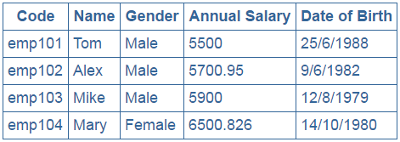   
  
We will use the same project that we have been working with so far in this video series.

**Step 1 :** Add a new **TypeScript**file to the **"employee"** folder. Name it **employeeList.component.ts**. Copy and paste the following code in it.

import { Component } from '@angular/core';

@Component({

    selector: 'list-employee',

    templateUrl: 'app/employee/employeeList.component.html',

    styleUrls: ['app/employee/employeeList.component.css']

})

export class EmployeeListComponent {

    employees: any[] = [

        {

            code: 'emp101', name: 'Tom', gender: 'Male',

            annualSalary: 5500, dateOfBirth: '25/6/1988'

        },

        {

            code: 'emp102', name: 'Alex', gender: 'Male',

            annualSalary: 5700.95, dateOfBirth: '9/6/1982'

        },

        {

            code: 'emp103', name: 'Mike', gender: 'Male',

            annualSalary: 5900, dateOfBirth: '12/8/1979'

        },

        {

            code: 'emp104', name: 'Mary', gender: 'Female',

            annualSalary: 6500.826, dateOfBirth: '14/10/1980'

        },

    ];

}

**Step 2 :** Add a new HTML page to the **"employee"** folder. Name it **employeeList.component.html**. Copy and paste the following code in it.  
  
**Please note :**

* **ngFor**is usually used to display an array of items
* Since **ngFor**is a structural directive it is prefixed with *
* **\*ngFor='let employee of employees'** - In this example 'employee' is called template input variable, which can be accessed by the <tr> element and any of it's child elements.
* **ngIf**structural directive displays the row **"No employees to display"** when employees property does not exist or when there are ZERO employees in the array.

<table>

    <thead>

        <tr>

            <th>Code</th>

            <th>Name</th>

            <th>Gender</th>

            <th>Annual Salary</th>

            <th>Date of Birth</th>

        </tr>

    </thead>

    <tbody>

        <tr *ngFor='let employee of employees'>

            <td>**{{**employee.code**}}**</td>

            <td>**{{**employee.name**}}**</td>

            <td>**{{**employee.gender**}}**</td>

            <td>**{{**employee.annualSalary**}}**</td>

            <td>**{{**employee.dateOfBirth**}}**</td>

        </tr>

        <tr *ngIf="!employees || employees.length==0">

            <td colspan="5">

                No employees to display

            </td>

        </tr>

    </tbody>

</table>

**Step 3 :**  Add a new **StyleSheet**to the **"employee"**folder. Name it **employeeList.component.css**. Copy and paste the following code in it.

table {

    color: #369;

    font-family: Arial, Helvetica, sans-serif;

    font-size: large;

    border-collapse: collapse;

}

td {

    border: 1px solid #369;

    padding:5px;

}

th{

    border: 1px solid #369;

    padding:5px;

}

**Step 4 :** In the root module, i.e **app.module.ts**, import employeeList component and add it to the declarations array as shown below. 

import { NgModule } from '@angular/core';

import { BrowserModule } from '@angular/platform-browser';

import { AppComponent } from './app.component';

import { EmployeeComponent } from './employee/employee.component';

import { EmployeeListComponent } from './employee/employeeList.component';

@NgModule({

    imports: [BrowserModule],

    declarations: [AppComponent, EmployeeComponent, EmployeeListComponent],

    bootstrap: [AppComponent]

})

export class AppModule { }

**Step 5 :** In the root component, i.e **app.component.ts**use employeeList component as a directive as shown below. 

import { Component } from '@angular/core';

@Component({

    selector: 'my-app',

    template: `<list-employee></list-employee>`

})

export class AppComponent { }

At this point, run the application and notice the employees are displayed in the table as expected.

### Angular ngFor trackBy

**Suggested Videos**  
[Part 14 - Angular2 event binding](https://www.youtube.com/watch?v=g8ofqqT_UAM) | [Text](http://csharp-video-tutorials.blogspot.com/2017/07/angular2-event-binding.html) | [Slides](http://csharp-video-tutorials.blogspot.com/2017/07/angular2-event-binding_4.html)  
[Part 15 - Two way data binding in angular 2](https://www.youtube.com/watch?v=aBf1nLGuVz8) | [Text](http://csharp-video-tutorials.blogspot.com/2017/07/two-way-data-binding-in-angular-2.html) | [Slides](http://csharp-video-tutorials.blogspot.com/2017/07/two-way-data-binding-in-angular-2_10.html)   
[Part 16 - Angular ngFor directive](https://www.youtube.com/watch?v=cS7syV0PjSs) | [Text](http://csharp-video-tutorials.blogspot.com/2017/07/angular-ngfor-directive.html) | [Slides](http://csharp-video-tutorials.blogspot.com/2017/07/angular-ngfor-directive_12.html)   
  
**In this video we will discuss**  
1. Using trackyBy with ngFor directive  
2. How to get the index of an item in a collection  
3. Identifying the first and the last elements in a collection  
4. Identifying even and odd elements in a collection

**Using trackyBy with ngFor directive :** 

* ngFor directive may perform poorly with large lists
* A small change to the list like, adding a new item or removing an existing item may trigger a cascade of DOM manipulations

For example, consider this code in **employeeList.component.ts**   
  
The constructor() initialises the employees property with 4 employee objects  
getEmployees() method returns another list of 5 employee objects (The 4 existing employees plus a new employee object) 

import { Component } from '@angular/core';

@Component({

    selector: 'list-employee',

    templateUrl: 'app/employee/employeeList.component.html',

    styleUrls: ['app/employee/employeeList.component.css']

})

export class EmployeeListComponent {

    employees: any[];

    constructor() {

        this.employees = [

            {

                code: 'emp101', name: 'Tom', gender: 'Male',

                annualSalary: 5500, dateOfBirth: '25/6/1988'

            },

            {

                code: 'emp102', name: 'Alex', gender: 'Male',

                annualSalary: 5700.95, dateOfBirth: '9/6/1982'

            },

            {

                code: 'emp103', name: 'Mike', gender: 'Male',

                annualSalary: 5900, dateOfBirth: '12/8/1979'

            },

            {

                code: 'emp104', name: 'Mary', gender: 'Female',

                annualSalary: 6500.826, dateOfBirth: '14/10/1980'

            },

        ];

    }

    getEmployees(): void {

        this.employees = [

            {

                code: 'emp101', name: 'Tom', gender: 'Male',

                annualSalary: 5500, dateOfBirth: '25/6/1988'

            },

            {

                code: 'emp102', name: 'Alex', gender: 'Male',

                annualSalary: 5700.95, dateOfBirth: '9/6/1982'

            },

            {

                code: 'emp103', name: 'Mike', gender: 'Male',

                annualSalary: 5900, dateOfBirth: '12/8/1979'

            },

            {

                code: 'emp104', name: 'Mary', gender: 'Female',

                annualSalary: 6500.826, dateOfBirth: '14/10/1980'

            },

            {

                code: 'emp105', name: 'Nancy', gender: 'Female',

                annualSalary: 6700.826, dateOfBirth: '15/12/1982'

            },

        ];

    }

}

Now look at this code in **employeeList.component.html**

<table>

    <thead>

        <tr>

            <th>Code</th>

            <th>Name</th>

            <th>Gender</th>

            <th>Annual Salary</th>

            <th>Date of Birth</th>

        </tr>

    </thead>

    <tbody>

        <tr *ngFor='let employee of employees'>

            <td>{{employee.code}}</td>

            <td>{{employee.name}}</td>

            <td>{{employee.gender}}</td>

            <td>{{employee.annualSalary}}</td>

            <td>{{employee.dateOfBirth}}</td>

        </tr>

        <tr *ngIf="!employees || employees.length==0">

            <td colspan="5">

                No employees to display

            </td>

        </tr>

    </tbody>

</table>

<br />

<button (click)='getEmployees()'>Refresh Employees</button>

**At the moment we are not using trackBy with ngFor directive**

1. When the page initially loads we see the 4 employees
2. When we click **"Refresh Employees"** button we see the fifth employee as well
3. It looks like it just added the additional row for the fifth employee. That's not true, it effectively teared down all the <tr> and <td> elements of all the employees and recreated them.
4. To confirm this launch browser developer tools by pressing F12.
5. Click on the "Elements" tab and expand the <table> and then <tbody> elements
6. At this point click the **"Refresh Employees"** button and you will notice all the <tr>elements are briefly highlighted indicating they are teared down and recreated.

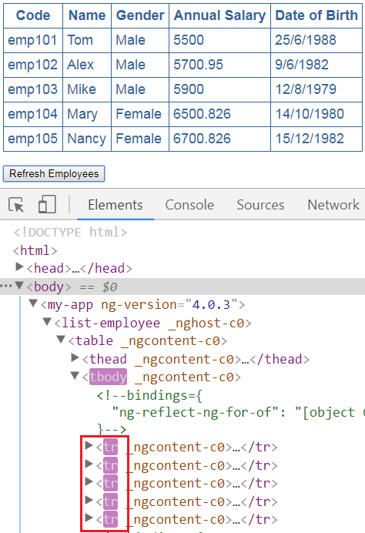   
  
This happens because Angular by default keeps track of objects using the object references. When we click **"Refresh Employees"** button we get different object references and as a result Angular has no choice but to tear down all the old DOM elements and insert the new DOM elements.   
  
Angular can avoid this churn with trackBy. The trackBy function takes the index and the current item as arguments and returns the unique identifier by which that item should be tracked. In our case we are tracking by Employee code. Add this method to **employeeList.component.ts**.  

trackByEmpCode(index: number, employee: any): string {

    return employee.code;

}

Make the following change in **employeeList.component.html** : Notice along with ngFor we also specified trackBy 

<tr *ngFor='let employee of employees; trackBy:trackByEmpCode'>

At this point, run the application and launch developer tools. When you click **"Refresh Employees"** first time, only the the row of the fifth employee is highlighted indicating only that<tr> element is added. On subsequent clicks, nothing is highlighted meaning none of the <tr> elements are teared down or added as the employees collection has not changed. Even now we get different object references when we click **"Refresh Employees"** button, but as Angular is now tracking employee objects using the employee code instead of object references, the respective DOM elements are not affected.   
  
**How to get the index of an item in a collection :** Notice in the example below, we are using the index property of the ngFor directive to store the index in a template input variable "i". The variable is then used in the <td> element where we want to display the index. We used the let keyword to create the template input variable "i".    
  
The index of an element is extremely useful when creating the HTML elements dynamically. We will discuss creating HTML elements dynamically in our upcoming videos. 

<table>

    <thead>

        <tr>

            <th>Code</th>

            <th>Name</th>

            <th>Gender</th>

            <th>Annual Salary</th>

            <th>Date of Birth</th>

            <th>Index</th>

        </tr>

    </thead>

    <tbody>

        <tr *ngFor='let employee of employees; let i=index'>

            <td>{{employee.code}}</td>

            <td>{{employee.name}}</td>

            <td>{{employee.gender}}</td>

            <td>{{employee.annualSalary}}</td>

            <td>{{employee.dateOfBirth}}</td>

            <td>{{i}}</td>

        </tr>

        <tr *ngIf="!employees || employees.length==0">

            <td colspan="5">

                No employees to display

            </td>

        </tr>

    </tbody>

</table>

Notice the index of the element is displayed int the last <td> element   
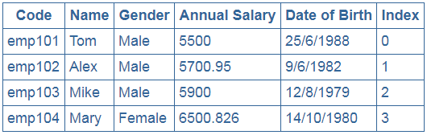   
  
**Identifying the first and the last element in a collection :** Use the first and last properties of the ngFor directive to find if an element is the first or last element respectively.   
  
Modify the code in **employeeList.component.html** as shown below. 

<table>

    <thead>

        <tr>

            <th>Code</th>

            <th>Name</th>

            <th>Gender</th>

            <th>Annual Salary</th>

            <th>Date of Birth</th>

            <th>Is First</th>

            <th>Is Last</th>

        </tr>

    </thead>

    <tbody>

        <tr *ngFor='let employee of employees; let isFirst = first; let isLast = last'>

            <td>{{employee.code}}</td>

            <td>{{employee.name}}</td>

            <td>{{employee.gender}}</td>

            <td>{{employee.annualSalary}}</td>

            <td>{{employee.dateOfBirth}}</td>

            <td>{{isFirst}}</td>

            <td>{{isLast}}</td>

        </tr>

        <tr *ngIf="!employees || employees.length==0">

            <td colspan="5">

                No employees to display

            </td>

        </tr>

    </tbody>

</table>

<br />

<button (click)='getEmployees()'>Refresh Employees</button>

The output is shown below   
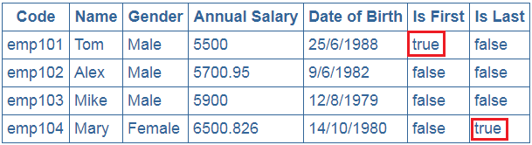  
  
**Identifying even and odd element in a collection :** This is similar to identifying first and last element in a collection. Instead of using first and last properties, use even and odd properties.   
  
Here is the code in **employeeList.component.html** 

<table>

    <thead>

        <tr>

            <th>Code</th>

            <th>Name</th>

            <th>Gender</th>

            <th>Annual Salary</th>

            <th>Date of Birth</th>

            <th>Is Even</th>

            <th>Is Odd</th>

        </tr>

    </thead>

    <tbody>

        <tr *ngFor='let employee of employees; let isEven = even; let isOdd = odd'>

            <td>{{employee.code}}</td>

            <td>{{employee.name}}</td>

            <td>{{employee.gender}}</td>

            <td>{{employee.annualSalary}}</td>

            <td>{{employee.dateOfBirth}}</td>

            <td>{{isEven}}</td>

            <td>{{isOdd}}</td>

        </tr>

        <tr *ngIf="!employees || employees.length==0">

            <td colspan="5">

                No employees to display

            </td>

        </tr>

    </tbody>

</table>

<br />

<button (click)='getEmployees()'>Refresh Employees</button>

The output is shown below   
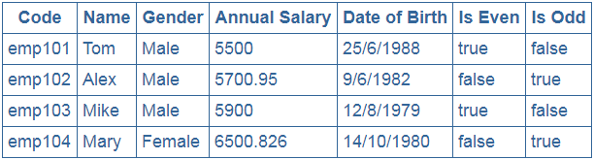

### Angular pipes

**Suggested Videos**  
[Part 15 - Two way data binding in angular 2](https://www.youtube.com/watch?v=aBf1nLGuVz8) | [Text](http://csharp-video-tutorials.blogspot.com/2017/07/two-way-data-binding-in-angular-2.html) | [Slides](http://csharp-video-tutorials.blogspot.com/2017/07/two-way-data-binding-in-angular-2_10.html)  
[Part 16 - Angular ngFor directive](https://www.youtube.com/watch?v=cS7syV0PjSs) | [Text](http://csharp-video-tutorials.blogspot.com/2017/07/angular-ngfor-directive.html) | [Slides](http://csharp-video-tutorials.blogspot.com/2017/07/angular-ngfor-directive_12.html)   
[Part 17 - Angular ngFor trackBy](https://www.youtube.com/watch?v=dEIg-PR4Tew) | [Text](http://csharp-video-tutorials.blogspot.com/2017/07/angular-ngfor-trackby.html) | [Slides](http://csharp-video-tutorials.blogspot.com/2017/07/angular-ngfor-trackby_13.html)  
  
In this video we will discuss **Pipes in Angular with examples.**

**Pipes in Angular**

* Transform data before display
* Built in pipes include lowercase, uppercase, decimal, date, percent, currency etc
* To apply a pipe on a bound property use the pipe character " | "  
  <td>{{employee.code | uppercase}}</td>
* We can also chain pipes<td>{{employee.dateOfBirth | date:'fullDate' |uppercase }}</td>
* Pass parameters to pipe using colon " : "  
  <td>{{employee.annualSalary | currency:'USD':true:'1.3-3'}}</td>

<td>{{employee.dateOfBirth | date:'fullDate'}}</td>

<td>{{employee.dateOfBirth | date:'dd/MM/y'}}</td>

* Custom pipes can be created
* To read more about angular built-in pipes

|  |  |
| --- | --- |
| **Pipe** | **URL** |
| Date | <https://angular.io/api/common/DatePipe> |
| Decimal | <https://angular.io/api/common/DecimalPipe> |
| Currency | <https://angular.io/api/common/CurrencyPipe> |
| Percent | <https://angular.io/api/common/PercentPipe> |

**Please note :** If you get the following error, chances are that your date is not in mm/dd/yyyy format. To fix this error please change the date format to mm/dd/yyyy or create a custom pipe  
InvalidPipeArgument: '14/10/1980' for pipe 'DatePipe'   
  
**Angular Pipe Examples:**  
  
uppercase pipe in this example converts employee code to uppercase  
<td>{{employee.code | uppercase}}</td>   
  
**Output :**   
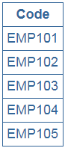   
  
In this example, we have chained date and uppercase pipes.  
<td>{{employee.dateOfBirth | date:'fullDate' | uppercase }}</td>   
  
**Output :**   
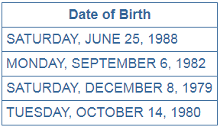   
  
In this example we are passing a single parameter to date pipe. With the parameter we specified we want the date format to be dd/mm/yyyy  
<td>{{employee.dateOfBirth | date:'dd/MM/y'}}</td>   
  
Output :    
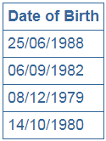   
  
For the list of date pipe parameter values please check the following article  
<https://angular.io/api/common/DatePipe>  
  
In this example we are passing 3 parameters to the currency pipe  
<td>{{employee.annualSalary | currency:'USD':true:'1.3-3'}}</td>

1. The first parameter is the currencyCode
2. The second parameter is boolean - True to display currency symbol, false to display currency code
3. The third parameter ('1.3-3') specifies the number of integer and fractional digits

Output :    
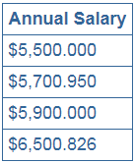

### Angular custom pipe

**Suggested Videos**  
[Part 16 - Angular ngFor directive](https://www.youtube.com/watch?v=cS7syV0PjSs) | [Text](http://csharp-video-tutorials.blogspot.com/2017/07/angular-ngfor-directive.html) | [Slides](http://csharp-video-tutorials.blogspot.com/2017/07/angular-ngfor-directive_12.html)  
[Part 17 - Angular ngFor trackBy](https://www.youtube.com/watch?v=dEIg-PR4Tew) | [Text](http://csharp-video-tutorials.blogspot.com/2017/07/angular-ngfor-trackby.html) | [Slides](http://csharp-video-tutorials.blogspot.com/2017/07/angular-ngfor-trackby_13.html)   
[Part 18 - Angular Pipes](https://www.youtube.com/watch?v=jAUwKOLNpjQ) | [Text](http://csharp-video-tutorials.blogspot.com/2017/07/angular-pipes.html) | [Slides](http://csharp-video-tutorials.blogspot.com/2017/07/angular-pipes_17.html)  
  
In this video we will discuss **creating a Custom Pipe in Angular**. Let us understand this with an example.

Here is what we want to do. Depending on the gender of the employee, we want to display Mr. or Miss. prefixed to the employee name as shown below.   
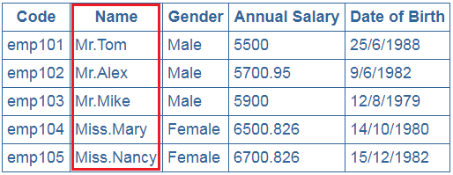

**Step 1 :** To achieve this let's create a custom pipe called employeeTitlePipe. Right click on the "employee" folder and add a new TypeScript file. Name it "employeeTitle.pipe.ts". Copy and paste the following code.   
  
**Code Explanation :**

* Import Pipe decorator and PipeTransform interface from Angular core
* Notice "EmployeeTitlePipe" class is decorated with Pipe decorator to make it an Angular pipe
* name property of the pipe decorator is set to employeeTitle. This name can then be used on any HTML page where you want this pipe functionality.
* EmployeeTitlePipe class implements the PipeTransform interface. This interface has one method transform() which needs to be implemented.
* Notice the transform method has 2 parameters. value parameter will receive the name of the employee and gender parameter receives the gender of the employee. The method returns a string i.e Mr. or Miss. prefixed to the name of the employee depending on their gender.

import { Pipe, PipeTransform } from '@angular/core';

@Pipe({

    name: 'employeeTitle'

})

export class EmployeeTitlePipe implements PipeTransform {

    transform(value: string, gender: string): string {

        if (gender.toLowerCase() == "male")

            return "Mr." + value;

        else

            return "Miss." + value;

    }

}

**Step 2 :** Register "EmployeeTitlePipe" in the angular module where we need it. In our case we need it in the root module. So in app.module.ts file, import the EmployeeTitlePipe and include it in the "declarations" array of NgModule decorator 

import { EmployeeTitlePipe } from './employee/employeeTitle.pipe'

@NgModule({

    imports: [BrowserModule],

    declarations: [AppComponent, EmployeeComponent,

                   EmployeeListComponent, EmployeeTitlePipe],

    bootstrap: [AppComponent]

})

export class AppModule { }

**Step 3 :** In "employeeList.component.html" use the "EmployeeTitlePipe" as shown below. Notice we are passing employee gender as an argument for the gender parameter of our custom pipe. Employee name gets passed automatically.

<tr *ngFor='let employee of employees;'>

    <td>{{employee.code}}</td>

    <td>{{employee.name | employeeTitle:employee.gender}}</td>

    <td>{{employee.gender}}</td>

    <td>{{employee.annualSalary}}</td>

    <td>{{employee.dateOfBirth}}</td>

</tr>

### Angular 2 container and nested components

**Suggested Videos**  
[Part 17 - Angular ngFor trackBy](https://www.youtube.com/watch?v=dEIg-PR4Tew) | [Text](http://csharp-video-tutorials.blogspot.com/2017/07/angular-ngfor-trackby.html) | [Slides](http://csharp-video-tutorials.blogspot.com/2017/07/angular-ngfor-trackby_13.html)  
[Part 18 - Angular Pipes](https://www.youtube.com/watch?v=jAUwKOLNpjQ) | [Text](http://csharp-video-tutorials.blogspot.com/2017/07/angular-pipes.html) | [Slides](http://csharp-video-tutorials.blogspot.com/2017/07/angular-pipes_17.html)   
[Part 19 - Angular custom pipe](https://www.youtube.com/watch?v=XRplR3Srr1k) | [Text](http://csharp-video-tutorials.blogspot.com/2017/07/angular-custom-pipe.html) | [Slides](http://csharp-video-tutorials.blogspot.com/2017/07/angular-custom-pipe_18.html)  
  
**In this video and in the next few videos we will discuss**

* What is a nested component
* What is a container component
* Passing data from the nested component to container component
* Passing data from the container component to nested component
* Along the way we will discuss component input and output properties
* Creating custom events using EventEmitter class
* What is ng-container directive and it's use

We will use the following example to understand all of the above concepts. Notice we have a table that displays a list of employees.    
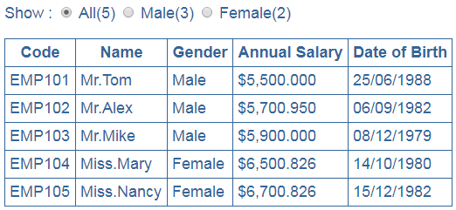

Above the table we have 3 radio buttons. Next to each radio button we also have the count of employees.    
passing data between components angular 2   
  
All(5) radio button has the total count of employees. Male(3) radio button has the total count of male employees and the Female(2) radio button has the total count of female employees.    
  
At the moment All(5) radio button is selected, so all the employees are displayed in the table. If I select Male(3) radio button, then only the 3 male employees should be displayed in the table. Along the same lines,if Female(2) radio button is selected only the female employees should be displayed.   
  
**As we develop this example, we will understand all the following concepts.**

* What is a container and nested component
* Passing data from the nested component to container component and vice-versa
* Component input and output properties
* Creating custom events using EventEmitter class
* What is ng-container directive and it's use

**What is a container and nested component :** In the example below, we have 2 components  
  
One of the component displays the list of employees. We have already built this component in our previous videos in this series. We named this component EmployeeListComponent.  
  
The other component displays the radio buttons and the count of employees. We have not created this component yet. We will create it in this video. We will call this component EmployeeCountComponent.  
  
We will nest EmployeeCountComponent in EmployeeListComponent. So EmployeeCountComponent becomes the nested component or child component and EmployeeListComponent becomes the container component or parent component.   
  
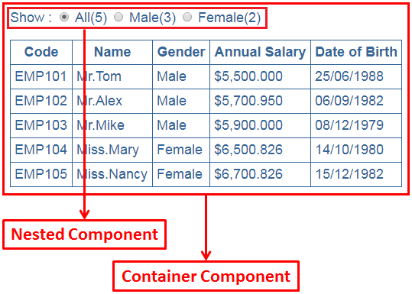   
  
We have already implemented the required code for EmployeeListComponent in our previous videos as shown below.  
  
**employeeList.component.ts** 

import { Component } from '@angular/core';

@Component({

    selector: 'list-employee',

    templateUrl: 'app/employee/employeeList.component.html',

    styleUrls: ['app/employee/employeeList.component.css']

})

export class EmployeeListComponent {

    employees: any[];

    constructor() {

        this.employees = [

            {

                code: 'emp101', name: 'Tom', gender: 'Male',

                annualSalary: 5500, dateOfBirth: '6/25/1988'

            },

            {

                code: 'emp102', name: 'Alex', gender: 'Male',

                annualSalary: 5700.95, dateOfBirth: '9/6/1982'

            },

            {

                code: 'emp103', name: 'Mike', gender: 'Male',

                annualSalary: 5900, dateOfBirth: '12/8/1979'

            },

            {

                code: 'emp104', name: 'Mary', gender: 'Female',

                annualSalary: 6500.826, dateOfBirth: '10/14/1980'

            },

            {

                code: 'emp105', name: 'Nancy', gender: 'Female',

                annualSalary: 6700.826, dateOfBirth: '12/15/1982'

            },

        ];

    }

}

**employeeList.component.html** 

<table>

    <thead>

        <tr>

            <th>Code</th>

            <th>Name</th>

            <th>Gender</th>

            <th>Annual Salary</th>

            <th>Date of Birth</th>

        </tr>

    </thead>

    <tbody>

        <tr *ngFor="let employee of employees;">

            <td>{{employee.code | uppercase}}</td>

            <td>{{employee.name | employeeTitle:employee.gender }}</td>

            <td>{{employee.gender}}</td>

            <td>{{employee.annualSalary | currency:'USD':true:'1.3-3'}}</td>

            <td>{{employee.dateOfBirth | date:'dd/MM/y'}}</td>

        </tr>

        <tr *ngIf="!employees || employees.length==0">

            <td colspan="5">

                No employees to display

            </td>

        </tr>

    </tbody>

</table>

**employeeList.component.css** 

table {

    color: #369;

    font-family: Arial, Helvetica, sans-serif;

    font-size: large;

    border-collapse: collapse;

}

td {

    border: 1px solid #369;

    padding:5px;

}

th{

    border: 1px solid #369;

    padding:5px;

}

Now let's create the EmployeeCountComponent. Add a new TypeScript file to the employee folder. Name it employeeCount.component.ts. Copy and paste the following code.   
  
**employeeCount.component.ts**

* We have set select='employee-count'. We can use this selector as a directive where we want to use this component. We are going to nest this component inside EmployeeListComponent using employee-count selector as a directive.
* We have 3 properties (all, male and Female). At the moment we have hard coded the values. In our next video we will discuss how to pass the values for these properties from the container component i.e from the EmployeeListComponent.

import { Component } from '@angular/core';

@Component({

    selector: 'employee-count',

    templateUrl: 'app/employee/employeeCount.component.html',

    styleUrls: ['app/employee/employeeCount.component.css']

})

export class EmployeeCountComponent {

    all: number = 10;

    male: number = 5;

    female: number = 5;

}

Add a new StyleSheet to the employee folder. Name it employeeCount.component.css. Copy and paste the following style class.   
  
**employeeCount.component.css** 

.radioClass {

    color: #369;

    font-family: Arial, Helvetica, sans-serif;

    font-size: large;

}

Now let's add the view template for EmployeeCountComponent. Add a new HTML page to the employee folder. Name it employeeCount.component.html. Copy and paste the following html.   
  
**employeeCount.component.html**  
Notice we have 3 radio buttons and bound them to the 3 properties (all, male, female) we have in the component class. We are using interpolation for data-binding. 

<span class="radioClass">Show : </span>

<input type="radio" name="options" />

<span class="radioClass">{{"All(" + all + ")"}}</span>

<input name="options" type="radio">

<span class="radioClass">{{"Male(" + male + ")"}}</span>

<input name="options" type="radio">

<span class="radioClass">{{"Female(" + female + ")"}}</span>

Nest EmployeeCountComponent in EmployeeListComponent component. To do this, use EmployeeCountComponent selector (employee-count) as a directive <employee-count></employee-count> on EmployeeListComponent component as shown below. 

<employee-count></employee-count>

<br /><br />

<table>

    <thead>

        <tr>

            <th>Code</th>

            <th>Name</th>

            <th>Gender</th>

            <th>Annual Salary</th>

            <th>Date of Birth</th>

        </tr>

    </thead>

    <tbody>

        <tr *ngFor="let employee of employees;">

            <td>{{employee.code | uppercase}}</td>

            <td>{{employee.name | employeeTitle:employee.gender }}</td>

            <td>{{employee.gender}}</td>

            <td>{{employee.annualSalary | currency:'USD':true:'1.3-3'}}</td>

            <td>{{employee.dateOfBirth | date:'dd/MM/y'}}</td>

        </tr>

        <tr *ngIf="!employees || employees.length==0">

            <td colspan="5">

                No employees to display

            </td>

        </tr>

    </tbody>

</table>

Finally, declare EmployeeCountComponent in module.ts file. Please make sure you import the component first and then add it to the declarations array of @NgModule decorator. 

import { EmployeeCountComponent } from './employee/employeeCount.component';

@NgModule({

    imports: [BrowserModule, FormsModule],

    declarations: [AppComponent, EmployeeComponent,

        EmployeeListComponent, EmployeeTitlePipe, EmployeeCountComponent],

    bootstrap: [AppComponent]

})

export class AppModule { }

At this point, run the project and you should see employee count radio buttons and the employee list.   
  
At the moment the employee counts are hard coded with in the EmployeeCountComponent. In our next video we will discuss how to pass the count values from the container component i.e from the EmployeeListComponent to the nested component i.e EmployeeCountComponent.

### Angular component input properties

**Suggested Videos**  
[Part 18 - Angular Pipes](https://www.youtube.com/watch?v=jAUwKOLNpjQ) | [Text](http://csharp-video-tutorials.blogspot.com/2017/07/angular-pipes.html) | [Slides](http://csharp-video-tutorials.blogspot.com/2017/07/angular-pipes_17.html)  
[Part 19 - Angular custom pipe](https://www.youtube.com/watch?v=XRplR3Srr1k) | [Text](http://csharp-video-tutorials.blogspot.com/2017/07/angular-custom-pipe.html) | [Slides](http://csharp-video-tutorials.blogspot.com/2017/07/angular-custom-pipe_18.html)   
[Part 20 - Angular 2 container and nested components](https://www.youtube.com/watch?v=vk2kTDdh5wc) | [Text](http://csharp-video-tutorials.blogspot.com/2017/07/angular-2-container-and-nested.html) | [Slides](http://csharp-video-tutorials.blogspot.com/2017/07/angular-2-container-and-nested_19.html)  
  
In this video we will discuss **how to pass data from the container component to the nested component using input properties**.    
  
This is continuation to [Part 20](https://www.youtube.com/watch?v=vk2kTDdh5wc), so please watch [Part 20](https://www.youtube.com/watch?v=vk2kTDdh5wc) from [Angular 2 tutorial](https://www.youtube.com/playlist?list=PL6n9fhu94yhWqGD8BuKuX-VTKqlNBj-m6) before proceeding. We will be working with the same example, we started in [Part 20](https://www.youtube.com/watch?v=vk2kTDdh5wc).

At the moment the count of employees displayed against each radio button are hard-coded with in the EmployeeCountComponent.   
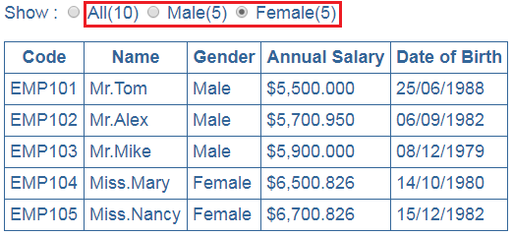

Here is the code in **employeeCount.component.ts** file : Notice the values for the 3 properties (all, male, female) are hard-coded. We want the values for these 3 properties to be passed from the container component i.e EmployeeListComponent. 

export class EmployeeCountComponent {

    all: number = 10;

    male: number = 5;

    female: number = 5;

}

Convert a component property to an input property using @Input decorator : To be able to pass the values for these 3 properties from the container component to the nested component we need to decorate the properties with @Input() decorator. Decorating a property with @Input() decorator makes the property an input property. Notice I have also removed the default hard-coded values, as we will be passing the values from the parent component i.e EmployeeListComponent. To be able to use the @Input() decorator we will have to first import it from @angular/core. 

import { Component, Input } from '@angular/core';

@Component({

    selector: 'employee-count',

    templateUrl: 'app/employee/employeeCount.component.html',

    styleUrls: ['app/employee/employeeCount.component.css']

})

export class EmployeeCountComponent {

    @Input()

    all: number;

    @Input()

    male: number;

    @Input()

    female: number;

}

**Passing data from the parent component to the child component :** There are 2 modifications that we need to do in EmployeeListComponent to be able to pass values from the parent component i.e EmployeeListComponent to the child component i.e EmployeeCountComponent. The first change is in EmployeeListComponent TypeScript file as shown below. Notice I have introduced 3 methods that return male employees count, female employees count and total employees count. 

import { Component } from '@angular/core';

@Component({

    selector: 'list-employee',

    templateUrl: 'app/employee/employeeList.component.html',

    styleUrls: ['app/employee/employeeList.component.css']

})

export class EmployeeListComponent {

    employees: any[];

    constructor() {

        this.employees = [

            {

                code: 'emp101', name: 'Tom', gender: 'Male',

                annualSalary: 5500, dateOfBirth: '6/25/1988'

            },

            {

                code: 'emp102', name: 'Alex', gender: 'Male',

                annualSalary: 5700.95, dateOfBirth: '9/6/1982'

            },

            {

                code: 'emp103', name: 'Mike', gender: 'Male',

                annualSalary: 5900, dateOfBirth: '12/8/1979'

            },

            {

                code: 'emp104', name: 'Mary', gender: 'Female',

                annualSalary: 6500.826, dateOfBirth: '10/14/1980'

            },

            {

                code: 'emp105', name: 'Nancy', gender: 'Female',

                annualSalary: 6700.826, dateOfBirth: '12/15/1982'

            },

        ];

    }

    getTotalEmployeesCount(): number {

        return this.employees.length;

    }

    getMaleEmployeesCount(): number {

        return this.employees.filter(e => e.gender === 'Male').length;

    }

    getFemaleEmployeesCount(): number {

        return this.employees.filter(e => e.gender === 'Female').length;

    }

}

**Please note :** In the filter method we are using tripple equals (===) instead of double equals (==). The table below explains single, double and tripple equals in TypeScript. 

|  |  |
| --- | --- |
| **Operator** | **Use to** |
| = | Assign a value |
| == | Compare two values |
| === | Compare two values and their types |

The second change is in the view template of EmployeeListComponent i.e **employeeList.component.html** file. Notice with in <employee-count> directive we are using property binding to bind the properties (all, male, female) of the nested component (EmployeeCountComponent) with the 3 methods in the container component (EmployeeListComponent). 

<employee-count [all]="getTotalEmployeesCount()"

                [male]="getMaleEmployeesCount()"

                [female]="getFemaleEmployeesCount()">

</employee-count>

<br /><br />

<table>

    <thead>

        <tr>

            <th>Code</th>

            <th>Name</th>

            <th>Gender</th>

            <th>Annual Salary</th>

            <th>Date of Birth</th>

        </tr>

    </thead>

    <tbody>

        <tr *ngFor="let employee of employees;">

            <td>{{employee.code | uppercase}}</td>

            <td>{{employee.name | employeeTitle:employee.gender }}</td>

            <td>{{employee.gender}}</td>

            <td>{{employee.annualSalary | currency:'USD':true:'1.3-3'}}</td>

            <td>{{employee.dateOfBirth | date:'dd/MM/y'}}</td>

        </tr>

        <tr *ngIf="!employees || employees.length==0">

            <td colspan="5">

                No employees to display

            </td>

        </tr>

    </tbody>

</table>

At this point, save all the changes and run the application and we see the correct count of employee next to each radio button.   
  
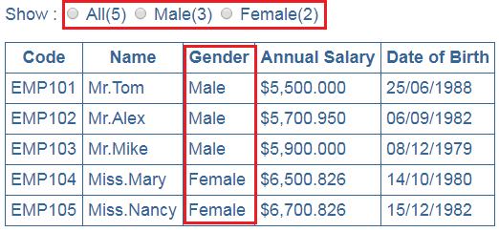   
  
Now, let's add the following new employee object to the to the employees array in EmployeeListComponent.

{

    code: 'emp106', name: 'Steve', gender: 'Male',

    annualSalary: 7700.481, dateOfBirth: '11/18/1979'

}

Save changes and reload the web page and notice that All count and Male count is increased by 1 as expected.   
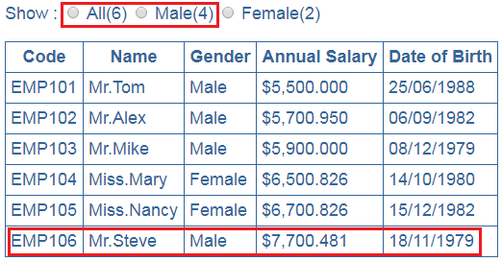   
  
At the moment when we click the radio buttons nothing happens. In our next video we will discuss **how to pass data from the child component to the parent component**i.e when a radio button checked event is raised in the child component, we want to know about it in the parent component so we can react and decide which employees to show in the table depending on the selection of the radio button.

### Angular component output properties

**Suggested Videos**  
[Part 19 - Angular custom pipe](https://www.youtube.com/watch?v=XRplR3Srr1k) | [Text](http://csharp-video-tutorials.blogspot.com/2017/07/angular-custom-pipe.html) | [Slides](http://csharp-video-tutorials.blogspot.com/2017/07/angular-custom-pipe_18.html)  
[Part 20 - Angular 2 container and nested components](https://www.youtube.com/watch?v=vk2kTDdh5wc) | [Text](http://csharp-video-tutorials.blogspot.com/2017/07/angular-2-container-and-nested.html) | [Slides](http://csharp-video-tutorials.blogspot.com/2017/07/angular-2-container-and-nested_19.html)   
[Part 21 - Angular component input properties](https://www.youtube.com/watch?v=g7BB8hn6YR0) | [Text](http://csharp-video-tutorials.blogspot.com/2017/07/angular-component-input-properties.html) | [Slides](http://csharp-video-tutorials.blogspot.com/2017/07/angular-component-input-properties_24.html)  
  
**In this video we will discuss**

* How to pass user actions or user entered values or selections from the child component to the parent component using output properties.
* Along the way we will discuss creating custom events using angular EventEmitter class
* Finally what is ng-container directive and it's use

This is continuation to [Part 21](https://www.youtube.com/watch?v=g7BB8hn6YR0), so please watch [Part 21](https://www.youtube.com/watch?v=g7BB8hn6YR0) from [Angular 2 tutorial](https://www.youtube.com/playlist?list=PL6n9fhu94yhWqGD8BuKuX-VTKqlNBj-m6) before proceeding. We will be working with the same example, we started in [Part 20](https://www.youtube.com/watch?v=vk2kTDdh5wc).   
  
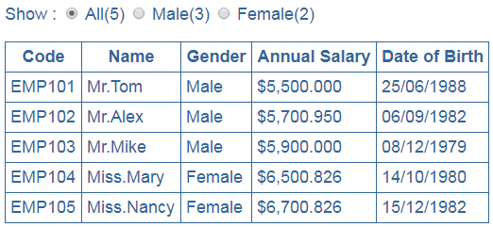

### Interfaces in Angular 2

**Suggested Videos**  
[Part 20 - Angular 2 container and nested components](https://www.youtube.com/watch?v=vk2kTDdh5wc) | [Text](http://csharp-video-tutorials.blogspot.com/2017/07/angular-2-container-and-nested.html) | [Slides](http://csharp-video-tutorials.blogspot.com/2017/07/angular-2-container-and-nested_19.html)  
[Part 21 - Angular component input properties](https://www.youtube.com/watch?v=g7BB8hn6YR0) | [Text](http://csharp-video-tutorials.blogspot.com/2017/07/angular-component-input-properties.html) | [Slides](http://csharp-video-tutorials.blogspot.com/2017/07/angular-component-input-properties_24.html)   
[Part 22 - Angular component output properties](https://www.youtube.com/watch?v=1jgqOt7s6Jo) | [Text](http://csharp-video-tutorials.blogspot.com/2017/07/angular-component-output-properties.html) | [Slides](http://csharp-video-tutorials.blogspot.com/2017/07/angular-component-output-properties_25.html)  
  
In this video we will discuss, **what are interfaces and when to use them in Angular**.   
  
**What is an Interface in TypeScript**  
If you have experience with any object oriented oriented programming language like C#, Java or C++, then you know an interface is an abstract type. It only contain declarations of properties, methods and events. The implementation for the interface members is provided by a class that implements the interface.

If a class that implements the interface fails to provide implementation for all the interface members, the language compiler raises an error alerting the developer that something has been missed.  
  
In general, an interface defines a contract (i.e the shape or structure of an API), that an implementing class must adhere to. Even in TypeScript we use the interface for the same purpose.

We know TypeScript is a strongly typed language. This means every property we define in a TypeScript class has a type associated with it. Similarly every method parameter and return type has a type. As you know by now, TypeScript has several built-in pre-defined types like string, number, boolean etc.  
  
However, the business objects that we usually create in real-world applications like Employee, Customer, Order, Invoice etc, does not have a pre-defined type. In this case, we can use an interface to create a custom type for our business object.  
  
Let us understand this with an example. We will use the same example we worked with in [Part 22](https://www.youtube.com/watch?v=1jgqOt7s6Jo) of [Angular 2 tutorial](https://www.youtube.com/playlist?list=PL6n9fhu94yhWqGD8BuKuX-VTKqlNBj-m6).  
  
Notice the below line of code in EmployeeListComponent class. The property **"employees"** is defined as an array of any type.  
employees: any[];   
  
Since we do not have a Type for employee object, we specified the type as any.  
  
There are 2 problems with the above line of code  
1. For the object properties in the array we do not get intellisense   
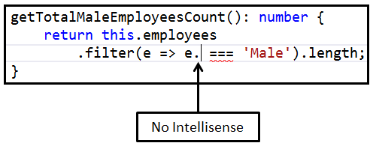   
  
2. Since we do not get intellisense, we are prone to making typographical errors and the compiler will not be able to flag them as errors. We will come to know about these errors only at runtime.   
  
Let's create a Type for employee using an interface as shown below. Add a new TypeScript file to the employee folder. Name it **employee.ts**. Copy and paste the following code. 

export interface IEmployee {

    code: string;

    name: string;

    gender: string;

    annualSalary: number;

    dateOfBirth: string;

}

With this IEmployee interface in place, we can now import and use the interface type as the type for "employees" property. The code in EmployeeListComponent class is shown below. 

import { IEmployee } from './employee';

export class EmployeeListComponent {

    employees: IEmployee[];

}

Since we have specified a type for the "employees" property, we now get intellisense for the object properties in the array   
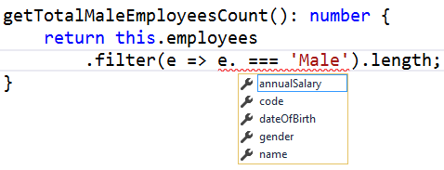   
  
If we make any typographical errors with the property names, we will get to know these errors right away at compile time.   
  
While we are here, let's discuss some of the concepts related to TypeScript interfaces. Conside the following interface. The code is commented and self-explanatory. 

export interface IEmployee {

    code: string;

    name: string;

    gender: string;

    annualSalary: number;

    dateOfBirth: string;

    // To make a property optional use a ?

    // A class that implements this interface need

    // not provide implementation for this property

    department?: string;

    computeMonthlySalary(annualSalary: number): number;

}

export class Employee implements IEmployee {

    // All the interface mandatory properties are defined

    public code: string;

    public name: string;

    public gender: string;

    public annualSalary: number;

    public dateOfBirth: string;

    // The above class properties are then initialized

    // using the constructor parameters. To do something

    // like this, TypeScript has a shorthand syntax which

    // reduces the amount of code we have to write

    constructor(code: string, name: string, gender: string,

        annualSalary: number, dateOfBirth: string) {

        this.code = code;

        this.name = name;

        this.gender = gender;

        this.annualSalary = annualSalary;

        this.dateOfBirth = dateOfBirth;

    }

    // Implementation of the interface method

    computeMonthlySalary(annualSalary: number): number {

        return annualSalary / 12;

    }

}

Here is the shorthand syntax to initialise class properties with constructor parameters 

export interface IEmployee {

    code: string;

    name: string;

    gender: string;

    annualSalary: number;

    dateOfBirth: string;

}

export class Employee implements IEmployee {

    constructor(public code: string, public name: string, public gender: string,

        public annualSalary: number, public dateOfBirth: string) {

    }

}

The above shorthand syntax is not limited to public class properties. We can also use it with private class properties. In the example below we have 2 private properties (firstName & lastName) which are initialised with class constructor. 

export class Employee {

    private firstName: string;

    private lastName: string;

    constructor(firstName: string, lastName: string) {

        this.firstName = firstName;

        this.lastName = lastName;

    }

}

We can rewrite the above code using shorthand syntax as shown below. In both the cases the generated JavaScript code is the same. 

export class Employee {

    constructor(private firstName: string, private lastName: string) {

    }

}

**Interfaces in TypeScript**

1. Use interface keyword to create an interface
2. It is common to prefix the interface name with capital letter **"I"**. However, some interfaces in Angular does not have the prefix **"I"**. For example, OnInit interface
3. Interface members are public by default and does not require explicit access modifiers. It is a compile time error to include an explicit access modifier. You will see an error message like - public modifier cannot appear on a type member.
4. A class that implements an interface must provide implementation for all the interface members unless the members are marked as optional using the **?**operator
5. Use the implements keyword to make a class implement an interface
6. TypeScript interfaces exist for developer convenience and are not used by Angular at runtime. During transpilation, no JavaScript code is generated for an interface. It is only used by Typescript for type checking during development.
7. To reduce the amount of code you have to write, consider using short-hand syntax to initialise class properties with constructor parameters

### Angular component lifecycle hooks

In this video we will discuss **Angular component lifecycle hooks**.   
  
**A component has a lifecycle managed by Angular. Angular**

1. Creates the component
2. Renders the component
3. Creates and renders the component children
4. Checks when the component data-bound properties change, and
5. Destroys the component before removing it from the DOM
6. To tap into and react when these life cycle events occur, angular offers several lifecycle hooks as shown in the image below.    
   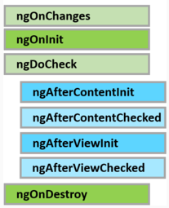   
     
   **The 3 most commonly used hooks are**

|  |  |
| --- | --- |
| **Life Cycle Hook** | **Purpose** |
| ngOnChanges | Executes, every time the value of an input property changes. The hook method receives a SimpleChanges object containing current and previous property values. This is called before ngOnInit |
| ngOnInit | Executes after the constructor and after ngOnChange hook for the first time. It is most commonly used for component initialisation and retrieving data from a database |
| ngOnDestroy | Executes just before angular destroys the component and generally used for performing cleanup |

1. **There are 3 simple steps to use the Life Cycle Hooks**  
   **Step 1 :** Import the Life Cycle Hook interface. For example, to use ngOnInit() life cycle hook, import OnInit interface.  
     
   import { OnInit } from '@angular/core';  
     
   **Step 2 :** Make the component class implement the Life Cycle Hook interface, using the implements keyword as shown below. This step is optional, but good to have so you will get editor support and flags errors at compile time if you incorrectly implement the interface method or make any typographical errors.  
     
   export class SimpleComponent implements OnInit { }  
     
   **Step 3 :** Write the implementation code for the life cycle interface method. Each interface has a single hook method whose name is the interface name prefixed with ng.  
     
   ngOnInit() {  
       console.log('OnInit Life Cycle Hook');  
   }  
     
   Let's understand ngOnChanges life cycle hook with a simple example. Here is what we want to do. As soon as the user starts typing into the text box, we want to capture the current and previous value and log it to the browser console as shown below. We can very easily achieve this by using the ngOnChanges life cycle hook.   
   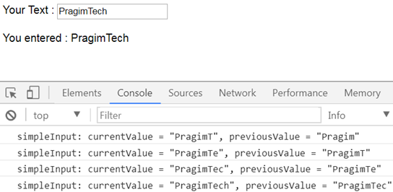   
     
   ngOnChanges, is called every time the value of an input property of a component changes. So first let's create a SimpleComponent with an input property as shown below. We will continue with the example we worked with in our previous video. Add a new folder in the App folder and name it Others. Add a new TypeScript file to this folder and name it - simple.component.ts. Copy and paste the following code which is commented and self explanatory.
2. // Step 1 : Import OnChanges and SimpleChanges
3. import { Component, Input, OnChanges, SimpleChanges } from '@angular/core';
4. // The selector "simple" will be used as the directive
5. // where we want to use this component. Notice we are
6. // also using the simpleInput property with interpolation
7. // to display the value it receives from the parent
8. // component
9. @Component({
10. selector: 'simple',
11. template: `You entered : {{simpleInput}}`
12. })
13. // Step 2 : Implement OnChanges Life Cycle Hook interface
14. export class SimpleComponent implements OnChanges {
15. // Input property. As and when this property changes
16. // ngOnChanges life cycle hook method is called
17. @Input() simpleInput: string;
18. // Step 3 : Implementation for the hook method
19. // This code logs the current and previous value
20. // to the console.
21. ngOnChanges(changes: SimpleChanges) {
22. for (let propertyName in changes) {
23. let change = changes[propertyName];
24. let current = JSON.stringify(change.currentValue);
25. let previous = JSON.stringify(change.previousValue);
26. console.log(propertyName + ': currentValue = '
27. + current + ', previousValue = ' + previous);
28. // The above line can be rewritten using
29. // placeholder syntax as shown below
30. // console.log(`${propertyName}: currentValue
31. // = ${current }, previousValue = ${previous }`);
32. }
33. }
34. }
35. Now copy and paste the following code in our root component - app.component.ts
36. import { Component } from '@angular/core';
37. // Notice we have placed the text box in this root component
38. // To keep the value in the textbox and the component property
39. // value "userText" in sync we are using 2 way data binding
40. // We have also bound userText property of this component
41. // to the input property of the SimpleComponent
42. @Component({
43. selector: 'my-app',
44. template: `Your Text : <input type='text' [(ngModel)]='userText'/>
45. <br/><br/>
46. <simple [simpleInput]='userText'></simple>
47. `
48. })
49. export class AppComponent {
50. userText: string = 'Pragim';
51. }
52. **Please note :** Do not forget to import and declare SimpleComponent in the root module - app.module.ts  
      
    At this point run the application and launch browser developer tools. As you start typing into the text box, the changes are logged to the console by the ngOnChanges life cycle hook method.  
      
    The steps for implementing the other component life cycle hook methods are very similar.

### Angular services tutorial

**Suggested Videos**  
[Part 22 - Angular component output properties](https://www.youtube.com/watch?v=1jgqOt7s6Jo) | [Text](http://csharp-video-tutorials.blogspot.com/2017/07/angular-component-output-properties.html) | [Slides](http://csharp-video-tutorials.blogspot.com/2017/07/angular-component-output-properties_25.html)  
[Part 23 - Interfaces in Angular 2](https://www.youtube.com/watch?v=Be3-ZWtC1Lo) | [Text](http://csharp-video-tutorials.blogspot.com/2017/07/interfaces-in-angular-2.html) | [Slides](http://csharp-video-tutorials.blogspot.com/2017/07/interfaces-in-angular-2_31.html)   
[Part 24 - Angular component lifecycle hooks](https://www.youtube.com/watch?v=RCLwwWQ8-V0) | [Text](http://csharp-video-tutorials.blogspot.com/2017/08/angular-component-lifecycle-hooks.html) | [Slides](http://csharp-video-tutorials.blogspot.com/2017/08/angular-component-lifecycle-hooks_1.html)   
  
**In this video we will discuss**

* Why we need a service in Angular
* Creating a service in Angular
* Injecting and using the service
* Difference between constructor and ngOnInit

**Why do we need a service in Angular**  
A service in Angular is generally used when you need to reuse data or logic across multiple components. Anytime you see logic or data-access duplicated across multiple components, think about refactoring that piece of logic or data-access code into a service. Using a service ensures we are not violating one of the Software principles - DRY ((Don't repeat yourself). The logic or data access is implemented once in a service, and the service can be used across all the components in our application.

Without the service you would have to repeat your code in each component. Imagine the overhead in terms of time and effort required to develop, debug, test and maintain the duplicated code across multiple places instead of having that duplicated code at one central place like a service and reusing that service where required.   
  
**Creating a service in Angular :** We will be working with the same example that we have been working with so far in this video series. Add a new TypeScript file to the "employee" folder and name it employee.service.ts. Copy and paste the following code. At the moment we have the data hard-coded in the service method. In a later video we will discuss retrieving data from a remote server using HTTP. 

import { Injectable } from '@angular/core';

import { IEmployee } from './employee';

// The @Injectable() decorator is used to inject other dependencies

// into this service. As our service does not have any dependencies

// at the moment, we may remove the @Injectable() decorator and the

// service works exactly the same way. However, Angular recomends

// to always use @Injectable() decorator to ensures consistency

@Injectable()

export class EmployeeService {

    getEmployees(): IEmployee[] {

        return [

            {

                code: 'emp101', name: 'Tom', gender: 'Male',

                annualSalary: 5500, dateOfBirth: '6/25/1988'

            },

            {

                code: 'emp102', name: 'Alex', gender: 'Male',

                annualSalary: 5700.95, dateOfBirth: '9/6/1982'

            },

            {

                code: 'emp103', name: 'Mike', gender: 'Male',

                annualSalary: 5900, dateOfBirth: '12/8/1979'

            },

            {

                code: 'emp104', name: 'Mary', gender: 'Female',

                annualSalary: 6500.826, dateOfBirth: '10/14/1980'

            },

            {

                code: 'emp105', name: 'Nancy', gender: 'Female',

                annualSalary: 6700.826, dateOfBirth: '12/15/1982'

            },

            {

                code: 'emp106', name: 'Steve', gender: 'Male',

                annualSalary: 7700.481, dateOfBirth: '11/18/1979'

            },

        ];

    }

}

**Injecting and using the service :** We need the employee service we created above in EmployeeListComponent. So let's import, register and use the Employee service in EmployeeListComponent as shown below.  

// Import OnInit Life Cycle Hook interface

import { Component, OnInit } from '@angular/core';

import { IEmployee } from './employee';

// Import EmployeeService

import { EmployeeService } from './employee.service';

@Component({

    selector: 'list-employee',

    templateUrl: 'app/employee/employeeList.component.html',

    styleUrls: ['app/employee/employeeList.component.css'],

    // Register EmployeeService in this component by

    // declaring it in the providers array

    providers: [EmployeeService]

})

// Make the class implement OnInit interface

export class EmployeeListComponent implements OnInit {

    employees: IEmployee[];

    selectedEmployeeCountRadioButton: string = 'All';

    // Inject EmployeeService using the constructor

    // The private variable _employeeService which points to

    // EmployeeService singelton instance is then available

    // throughout this class

    constructor(private _employeeService: EmployeeService) {

    }

    // In ngOnInit() life cycle hook call the getEmployees()

    // service method of EmployeeService using the private

    // variable _employeeService

    ngOnInit() {

        this.employees = this._employeeService.getEmployees();

    }

    getTotalEmployeesCount(): number {

        return this.employees.length;

    }

    getTotalMaleEmployeesCount(): number {

        return this.employees

            .filter(e => e.gender === 'Male').length;

    }

    getTotalFemaleEmployeesCount(): number {

        return this.employees.filter(e => e.gender === 'Female').length;

    }

    onEmployeeCountRadioButtonChange(selectedRadioButtonValue: string): void {

        this.selectedEmployeeCountRadioButton = selectedRadioButtonValue;

    }

}

Please do not forget to use the EmployeeListComponent selector (list-employee) as a directive in the root component - AppComponent (app.component.ts) as shown below. 

import { Component } from '@angular/core';

@Component({

    selector: 'my-app',

    template: `<list-employee></list-employee>`

})

export class AppComponent {

}

At this point, run the application and notice it works exactly the same way as before.    
  
The following line of code which calls the service, can be placed even in the constructor and the application still works exactly the same way as before. So what is the difference between a constructor and ngOnInit life cycle hook, and when to use one over the other.  
  
this.employees = this._employeeService.getEmployees();   
  
**Difference between constructor and ngOnInit**   
A class constructor is automatically called when an instance of the class is created. It is generally used to initialise the fields of the class and it's sub classes.   
  
ngOnInit is a life cycle hook method provided by Angular. ngOnInit is called after the constructor and is generally used to perform tasks related to Angular bindings. For example, ngOnInit is the right place to call a service method to fetch data from a remote server. We can also do the same using a class constructor, but the general rule of thumb is, tasks that are time consuming should use ngOnInit instead of the constructor. As fetching data from a remote server is time consuming, the better place for calling the service method is ngOnInit.  
  
So coming back to our example, the dependency injection is done using the class constructor and the actual service method call is issued from ngOnInit life cycle hook as shown below  
  
constructor(private _employeeService: EmployeeService) { }  
  
ngOnInit() {  
    this.employees = this._employeeService.getEmployees();  
}

### Angular and ASP.NET Web API

**Suggested Videos**  
[Part 23 - Interfaces in Angular 2](https://www.youtube.com/watch?v=Be3-ZWtC1Lo) | [Text](http://csharp-video-tutorials.blogspot.com/2017/07/interfaces-in-angular-2.html) | [Slides](http://csharp-video-tutorials.blogspot.com/2017/07/interfaces-in-angular-2_31.html)  
[Part 24 - Angular component lifecycle hooks](https://www.youtube.com/watch?v=RCLwwWQ8-V0) | [Text](http://csharp-video-tutorials.blogspot.com/2017/08/angular-component-lifecycle-hooks.html) | [Slides](http://csharp-video-tutorials.blogspot.com/2017/08/angular-component-lifecycle-hooks_1.html)   
[Part 25 - Angular services tutorial](https://www.youtube.com/watch?v=qAeh4jZTjCk) | [Text](http://csharp-video-tutorials.blogspot.com/2017/08/angular-services-tutorial.html) | [Slides](http://csharp-video-tutorials.blogspot.com/2017/08/angular-services-tutorial_2.html)  
  
In this video we will discuss **creating ASP.NET Web API service** that retrieves employees data from a database table. In our next video we will discuss, how to call this ASP.NET Web API service using Angular

**Step 1 :** Execute the following SQL Script using SQL Server Management studio. This script creates

* EmployeeDB database
* Creates the Employees table and populate it with sample data

Create Database EmployeeDB

Go

Use EmployeeDB

Go

Create table Employees

(

     code nvarchar(50) primary key,

     name nvarchar(50),

     gender nvarchar(50),

     annualSalary decimal(18,3),

     dateOfBirth nvarchar(50)

)

Go

Insert into Employees values ('emp101', 'Tom', 'Male', 5500, '6/25/1988')

Insert into Employees values ('emp102', 'Alex', 'Male', 5700.95, '9/6/1982')

Insert into Employees values ('emp103', 'Mike', 'Male', 5900, '12/8/1979')

Insert into Employees values ('emp104', 'Mary', 'Female', 6500.826, '10/14/1980')

Insert into Employees values ('emp105', 'Nancy', 'Female', 6700.826, '12/15/1982')

Insert into Employees values ('emp106', 'Steve', 'Male', 7700.481, '11/18/1979')

**Step 2 :** To keep Angular and Web API projects separate, let's create a new project for our Web API Service. Right click on **"Angular2Demo"** solution in the Solution Explorer and select Add - New Project.  
  
**Step 3 :**In the Add New Project window

1. Select "Visual C#" under "Installed - Templates"
2. From the middle pane select, ASP.NET Web Application
3. Name the project "EmployeeWebAPIService" and click "OK"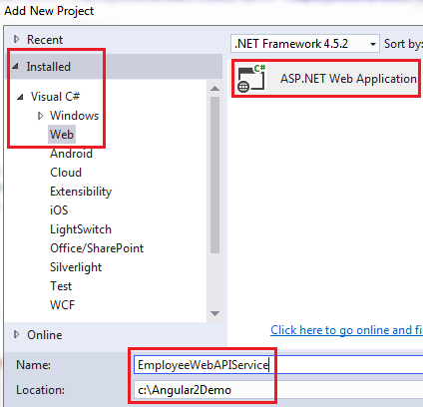

**Step 4 :** On the next window, select "Web API" and click "OK". At this point you should have the Web API project created.  
  
**Step 5 :** Add ADO.NET Entity Data Model to retrieve data from the database. Right click on "EmployeeWebAPIService" project and select Add - New Item

1. In the "Add New Item" window
2. Select "Data" from the left pane
3. Select ADO.NET Entity Data Model from the middle pane
4. In the Name text box, type EmployeeDataModel and click Add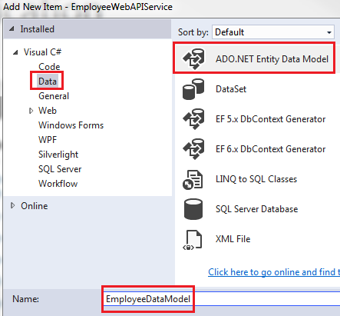

**Step 6 :** On the Entity Data Model Wizard, select "EF Designer from database" option and click next  
  
**Step 7 :** On the next screen, click "New Connection" button  
  
**Step 8 :** On "Connection Properties" window, set

1. Server Name = (local)
2. Authentication = Windows Authentication
3. Select or enter a database name = EmployeeDB
4. Click OK and then click Next

**Step 9 :** On the nex screen, select "Employees" table and click Finish.  
  
**Adding Web API Controller**  
  
1. Right click on the Controllers folder in EmployeeWebAPIService project and select Add - Controller  
  
2. Select "Web API 2 Controller - Empty" and click "Add"  
  
3. On the next screen set the Controller Name = EmployeesController and click Add  
  
4. Copy and paste the following code in EmployeesController.cs

using System.Collections.Generic;

using System.Linq;

using System.Web.Http;

namespace EmployeeWebAPIService.Controllers

{

    public class EmployeesController : ApiController

    {

        public IEnumerable<Employee> Get()

        {

            using(EmployeeDBEntities entities = new EmployeeDBEntities())

            {

                return entities.Employees.ToList();

            }

        }

        public Employee Get(string code)

        {

            using (EmployeeDBEntities entities = new EmployeeDBEntities())

            {

                return entities.Employees.FirstOrDefault(e => e.code == code);

            }

        }

    }

}

At this point when you navigate to /api/employees you will see all the employees as expected. However, when you navigate to /api/employees/emp101, we expect to see employee whose employee code is emp101, but we still see the list of all employees.   
This is because the parameter name for the Get() method in EmployeesController is "code"

public Employee Get(string code)

{

    using (EmployeeDBEntities entities = new EmployeeDBEntities())

    {

        return entities.Employees.FirstOrDefault(e => e.code == code);

    }

}

but in the default Web API route in WebApiConfig.cs file the parameter name is {id}. Change this to "code" as shown below

config.Routes.MapHttpRoute(

    name: "DefaultApi",

    routeTemplate: "api/{controller}/{code}",

    defaults: new { code = RouteParameter.Optional }

);

With this change if we navigate to /api/employees/emp101 we see just that employee whose employee code is "emp101"   
  
In our next video we will discuss,**how to call this ASP.NET Web API service using Angular**

### Angular 2 http service tutorial

**Suggested Videos**  
[Part 24 - Angular component lifecycle hooks](https://www.youtube.com/watch?v=RCLwwWQ8-V0) | [Text](http://csharp-video-tutorials.blogspot.com/2017/08/angular-component-lifecycle-hooks.html) | [Slides](http://csharp-video-tutorials.blogspot.com/2017/08/angular-component-lifecycle-hooks_1.html)  
[Part 25 - Angular services tutorial](https://www.youtube.com/watch?v=qAeh4jZTjCk) | [Text](http://csharp-video-tutorials.blogspot.com/2017/08/angular-services-tutorial.html) | [Slides](http://csharp-video-tutorials.blogspot.com/2017/08/angular-services-tutorial_2.html)   
[Part 26 - Angular and ASP.NET Web API](https://www.youtube.com/watch?v=FQ__z26TsHU) | [Text](http://csharp-video-tutorials.blogspot.com/2017/08/angular-and-aspnet-web-api.html) | [Slides](http://csharp-video-tutorials.blogspot.com/2017/08/angular-and-aspnet-web-api_7.html)  
  
**In this video we will discuss**  
How to call ASP.NET Web API service using Angular 2 http service. Though this example demonstrates calling ASP.NET Web API service, we can use this same approach to call any web service built using any server side technology. We will also briefly discuss Observable pattern

In our previous video we have created ASP.NET EmployeeWebAPIService. Here are the steps to call the Web API service using the Angular builtin http service.

**Step 1** - Import the angular HTTP module : The first step is to import HttpModule which is present in a separate javascript file - @angular/http. After the HttpModule is imported, include it in the imports array of the NgModule() decorator of our root module "AppModule" which is in "app.module.ts" file. With this change we can now start using the angular built-in http service throughout our application to access web services over HTTP. 

import { HttpModule } from '@angular/http';

@NgModule({

    imports: [

        BrowserModule,

        FormsModule,

        HttpModule],

    declarations: [

        AppComponent,

        EmployeeComponent,

        EmployeeListComponent,

        EmployeeTitlePipe,

        EmployeeCountComponent,

        SimpleComponent

    ],

    bootstrap: [AppComponent]

})

export class AppModule { }

**Step 2** - Modify angular EmployeeService to issue a GET request using the builtin http service : The angular EmployeeService is in employee.service.ts file. 

* Use the EmployeeService class constructor to inject Angular Http service. The injected http service can then be used anywhere in this class to call a web service over http.
* Since this Angular EmployeeService class has an injected dependency, @Injectable() decorator is required on this class. If there are no injectable dependencies then we may omit the @Injectable() decorator, but angular strongly recomends to use the @Injectable() decorator irrespective of there are injectible dependencies or not for consistency and future proof.
* Notice in the getEmployees() method, we are using the get() method of the angular http service to issue a get request over http. If you right click on get() method and go to it's definition you will notice that this method return Observable<Response>.
* Observable<Response> is not that useful to us, so we have set the return type of getEmployees() method to Observable<IEmployee[]>
* To convert Observable<Response> to Observable<IEmployee[]> we are using the map operator provided by rxjs.
* At the moment, we are not handling exceptions. We will discuss how to handle exceptions in our upcoming videos.

**What is an Observable**

* Observable is an asynchronous pattern. In the Observable pattern we have an Observable and an Observer. Observer observes the Observable. In many implementations an Observer is also called as a Subscriber.
* An Observable can have many Observers (also called Subscribers).
* Observable emits items or notifications over time to which an Observer (also called Subscriber) can subscribe.
* When a subscriber subscribes to an Observable, the subscriber also specifies a callback function.
* This subscriber callback function is notified as and when the Observable emits items or notifications.
* Within this callback function we write code to handle data itmes or notifications received from the Observable.

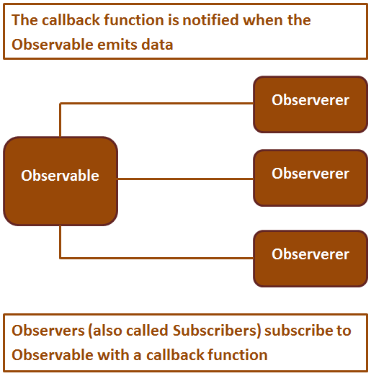 

import { Injectable } from '@angular/core';

import { IEmployee } from './employee';

// Import Http & Response from angular HTTP module

import { Http, Response } from '@angular/http';

// Import Observable from rxjs/Observable

import { Observable } from 'rxjs/Observable';

// Import the map operator

import 'rxjs/add/operator/map';

@Injectable()

export class EmployeeService {

    // Inject Angular http service

    constructor(private _http: Http) { }

    // Notice the method return type is Observable<IEmployee[]>

    getEmployees(): Observable<IEmployee[]> {

        // To convert Observable<Response> to Observable<IEmployee[]>

        // we are using the map operator

        return this._http.get('http://localhost:24535/api/employees')

            .map((response: Response) => <IEmployee[]>response.json());

    }

}

**Step 3** - Subscribe to the Observable returned by angular EmployeeService : EmployeeListComponent needs the employees data returned by the service. So in the ngOnInit() method of "employeeList.component.ts" use the subscribe method as shown below. 

ngOnInit() {

    this._employeeService.getEmployees()

        .subscribe(employeesData => this.employees = employeesData);

}

Notice to the subscribe() function we are passing an other arrow function as a parameter. This arrow function is called when the Observable emits an item. In our case the Observable emits an array of IEmployee objects. employeesData parameter receives the array of IEmployee objects, which we are then using to initialise employees property of the EmployeeListComponent class. We can specify upto 3 callback functions as parameters to the subscribe() method as shown below. 

|  |  |
| --- | --- |
| **Callback Method** | **Purpose** |
| onNext | The Observable calls this method whenever the Observable emits an item. The emitted item is passed as a parameter to this method |
| onError | The Observable calls this method if there is an error |
| onCompleted | The Observable calls this method after it has emitted all items, i.e after it has called onNext for the final time |

At the moment, in our example, we only have used onNext() callback method. In our upcoming videos we will discuss using onError() method to handle exceptions. Using Visual Studio intellisense you can see these 3 callback functions of the subscribe() method.   
  
At this point, run the application. The data may not display and you see the following error in browser developer tools.  
Cannot read property 'length' of undefined - at EmployeeListComponent.getTotalEmployeesCount   
  
**Reson for the above error :**Consider this HTML in employeeList.component.html. Notice we are binding to the input properties (all, male and female) of <employee-count> component. 

<employee-count [all]="getTotalEmployeesCount()"

                [male]="getTotalMaleEmployeesCount()"

                [female]="getTotalFemaleEmployeesCount()"

                (countRadioButtonSelectionChanged)=

                "onEmployeeCountRadioButtonChange($event)">

</employee-count>

Here is the getTotalEmployeesCount() method which is binded to "all" property of <employee-count> component. 

getTotalEmployeesCount(): number {

    return this.employees.length;

}

The Web API call to retrieve is in ngOnInit(). Before the service call can initialise "employees" property of the EmployeeListComponent class, getTotalEmployeesCount() method is trying to access "length" property of "employees" property. "employees" property is still undefined at that point, so we get the error - Cannot read property 'length' of undefined. 

ngOnInit() {

    this._employeeService.getEmployees()

        .subscribe(employeesData => this.employees = employeesData);

}

To fix this error use angular structural directive *ngIf as shown below. This will delay the initialization of employee-count component until "employees" property is initialised. 

<employee-count *ngIf="employees" [all]="getTotalEmployeesCount()"

                [male]="getTotalMaleEmployeesCount()"

                [female]="getTotalFemaleEmployeesCount()"

                (countRadioButtonSelectionChanged)=

                "onEmployeeCountRadioButtonChange($event)">

</employee-count>

At this point if you run the application, you will see no employees on the web page and in the browser developer tools you will see the following error message  
No 'Access-Control-Allow-Origin' header is present on the requested resource. Origin 'http://localhost:12345' is therefore not allowed access.   
  
We get this error because our Angular application and Web API service are in different projects. Because they are present in different projects the port numbers are different. Since the port numbers are different, the request from the angular project to the web api project is a cross domain request which violates the same origin policy and as a result the browser blocks the request for security reasons.    
  
To learn more about same origin policy and Cross-origin resource sharing please watch Parts [14](https://www.youtube.com/watch?v=WKZLVqwpoiE) and [15](https://www.youtube.com/watch?v=nsnuIZX1C9A) from [ASP.NET Web API tutorial](https://www.youtube.com/playlist?list=PL6n9fhu94yhW7yoUOGNOfHurUE6bpOO2b)  
  
To fix this error include the following setting in web.config file of the Web API project

<system.webServer>

  <httpProtocol>

    <customHeaders>

      <add name="Access-Control-Allow-Origin" value="*" />

      <add name="Access-Control-Allow-Headers" value="Content-Type" />

      <add name="Access-Control-Allow-Methods"

           value="GET, POST, PUT, DELETE, OPTIONS" />

    </customHeaders>

  </httpProtocol>

</system.webServer>

Here is the complete **employeeList.component.html**

<employee-count *ngIf="employees" [all]="getTotalEmployeesCount()"

                [male]="getTotalMaleEmployeesCount()"

                [female]="getTotalFemaleEmployeesCount()"

                (countRadioButtonSelectionChanged)=

                "onEmployeeCountRadioButtonChange($event)">

</employee-count>

<br />

<br />

<table>

    <thead>

        <tr>

            <th>Code</th>

            <th>Name</th>

            <th>Gender</th>

            <th>Annual Salary</th>

            <th>Date of Birth</th>

        </tr>

    </thead>

    <tbody>

        <ng-container *ngFor="let employee of employees;">

            <tr *ngIf="selectedEmployeeCountRadioButton=='All' ||

                           selectedEmployeeCountRadioButton==employee.gender">

                <td>**{{**employee.code | uppercase**}}**</td>

                <td>**{{**employee.name | employeeTitle:employee.gender **}}**</td>

                <td>**{{**employee.gender**}}**</td>

                <td>**{{**employee.annualSalary | currency:'USD':true:'1.3-3'**}}**</td>

                <td>**{{**employee.dateOfBirth | date:'dd/MM/y'**}}**</td>

            </tr>

        </ng-container>

        <!--If the web service takes time to return data, the message in this <tr>

        is displayed. When the service call returns this message disappears

        and the employees data is displayed-->

        <tr *ngIf="!employees">

            <td colspan="5">

                Loading data. Please wait...

            </td>

        </tr>

        <!--This message is displayed if the web services does not return any data-->

        <tr *ngIf="employees && employees.length==0">

            <td colspan="5">

                No employee records to display

            </td>

        </tr>

    </tbody>

</table>

We can also use promises instead of Observables. We will discuss using promises in our upcoming videos.

### Angular 2 http error handling

**Suggested Videos**  
[Part 25 - Angular services tutorial](https://www.youtube.com/watch?v=qAeh4jZTjCk) | [Text](http://csharp-video-tutorials.blogspot.com/2017/08/angular-services-tutorial.html) | [Slides](http://csharp-video-tutorials.blogspot.com/2017/08/angular-services-tutorial_2.html)  
[Part 26 - Angular and ASP.NET Web API](https://www.youtube.com/watch?v=FQ__z26TsHU) | [Text](http://csharp-video-tutorials.blogspot.com/2017/08/angular-and-aspnet-web-api.html) | [Slides](http://csharp-video-tutorials.blogspot.com/2017/08/angular-and-aspnet-web-api_7.html)   
[Part 27 - Angular 2 http service tutorial](https://www.youtube.com/watch?v=DETRfgZGuk8) | [Text](http://csharp-video-tutorials.blogspot.com/2017/08/angular-2-http-service-tutorial.html) | [Slides](http://csharp-video-tutorials.blogspot.com/2017/08/angular-2-http-service-tutorial_8.html)  
  
In this video we will discuss **error handling in Angular**. This is continuation to [Part 27](https://www.youtube.com/watch?v=DETRfgZGuk8). Please watch [Part 27](https://www.youtube.com/watch?v=DETRfgZGuk8) from [Angular 2 tutorial](https://www.youtube.com/playlist?list=PL6n9fhu94yhWqGD8BuKuX-VTKqlNBj-m6) before proceeding.

When using http, to call a web service, errors may occur. When they do occur we want to handle these errors.

1. We use the catch operator to catch any exceptions that occur.   
  
2. Before we use the catch operator we have to import it, just like how we imported map operator.  
import 'rxjs/add/operator/catch';  
  
3. The catch operator can then be chained to the map operator.  
return this._http.get('http://localhost:24535/api/employeess')  
    .map((response: Response) => <IEmployee[]>response.json())  
    .catch(this.handleError);  
  
4. To the catch operator we are passing another method (handleError). This handleError() method is called when there is an exception.  
  
handleError(error: Response) {  
    console.error(error);  
    return Observable.throw(error);  
}  
  
5. In a real world application we may pass the error to a logging service to log the error to a file or a database table, so the developers can see these errors and fix them if required.  
  
6. In our case, to keep things simple we are logging to the browser console.   
  
7. Since we want the error message color to be red so it stands out, we are using console.error() method instead of console.log() method to log the error to the browser console.  
  
8. After we log the error, we are throwing the error back, so the components that use this service are notified about the error condition, so they can display a meaningful error message to the user.  
  
9. To use throw, we will have to import it from rxjs  
import 'rxjs/add/Observable/throw';  
  
Here is the complete code in **employee.service.ts** 

import { Injectable } from '@angular/core';

import { IEmployee } from './employee';

import { Http, Response } from '@angular/http';

import { Observable } from 'rxjs/Observable';

import 'rxjs/add/operator/map';

import 'rxjs/add/operator/catch';

import 'rxjs/add/Observable/throw';

@Injectable()

export class EmployeeService {

    constructor(private _http: Http) { }

    getEmployees(): Observable<IEmployee[]> {

        return this._http.get('http://localhost:24535/api/employees')

            .map((response: Response) => <IEmployee[]>response.json())

            .catch(this.handleError);

    }

    handleError(error: Response) {

        console.error(error);

        return Observable.throw(error);

    }

}

We are calling this service from EmployeeListComponent. So we need to handle the error we have thrown from the service and display a meaningful message to the user. We are subscribing to the service, in ngOnInit() life cycle hook of EmployeeListComponent.   
  
Notice there are 2 parameters to the subscribe() function. Both these parameters are arrow functions. The first arrow function is called when the Observable successfully emits an item. The second arrow function is called, when there is an error.   
  
ngOnInit() {  
    this._employeeService.getEmployees()  
        .subscribe(  
        employeesData => this.employees = employeesData,  
        error => {  
            console.error(error);  
            this.statusMessage = 'Problem with the service. Please try again after sometime';  
        });  
}   
  
Here is the complete code in employeeList.component.ts : Notice the code that is relevant to exception handling is commented and self-explanatory 

import { Component, OnInit } from '@angular/core';

import { IEmployee } from './employee';

import { EmployeeService } from './employee.service';

@Component({

    selector: 'list-employee',

    templateUrl: 'app/employee/employeeList.component.html',

    styleUrls: ['app/employee/employeeList.component.css'],

    providers: [EmployeeService]

})

export class EmployeeListComponent implements OnInit {

    employees: IEmployee[];

    // The view template will bind to this property to display

    // "Loading data. Please wait..." message when the data is

    // being loaded. If there is an error the second arrow

    // function in the subscribe method sets this property to

    // "Problem with the service. Please try again after sometime"

    statusMessage: string = 'Loading data. Please wait...';

    selectedEmployeeCountRadioButton: string = 'All';

    constructor(private _employeeService: EmployeeService) {

    }

    ngOnInit() {

        // The second arrow function sets the statusMessage property

        // to a meaningful message that can be displayed to the user

        this._employeeService.getEmployees()

            .subscribe(

            employeesData => this.employees = employeesData,

            error => {

                this.statusMessage =

                    'Problem with the service. Please try again after sometime';

            });

    }

    getTotalEmployeesCount(): number {

        return this.employees.length;

    }

    getTotalMaleEmployeesCount(): number {

        return this.employees

            .filter(e => e.gender === 'Male').length;

    }

    getTotalFemaleEmployeesCount(): number {

        return this.employees.filter(e => e.gender === 'Female').length;

    }

    onEmployeeCountRadioButtonChange(selectedRadioButtonValue: string): void {

        this.selectedEmployeeCountRadioButton = selectedRadioButtonValue;

    }

}

At this point run the application, and notice since we do not have any errors, that data is loaded as expected. Now let's introduce an error. In employee.component.ts file    
  
Change the url from   
http://localhost:24535/api/employees  
  
To (Notice the extra "s" at the end)  
http://localhost:24535/api/employeess  
  
At this point when you reload the page in the browser, you will see the message "Loading data. Please wait...", but the data never loads.    
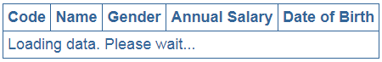   
  
Now launch browser developer tools and you will see the error message logged to the console by the service.   
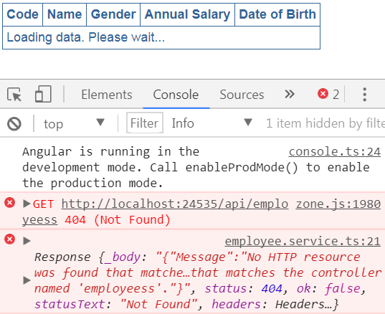   
  
This message - "Loading data. Please wait..." is misleading in this case. Instead we should be displaying a meaningful message like - "Problem with the service. Please try again after sometime".  
  
To do this in the view template of EmployeeListComponent (employeeList.component.html) bind to statusMessage property of the EmployeeListComponent class as shown below. 

<tr *ngIf="!employees">

    <td colspan="5">

        {{statusMessage}}

    </td>

</tr>

With the above change, while the service is busy retrieving data, we see the message "Loading data. Please wait..." and if there is an error we see the message "Problem with the service. Please try again after sometime"  
  
If you comment the following import statement in employee.service.ts, the exception handling still works as expected.  
import 'rxjs/add/Observable/throw';  
  
However, without the above import statement in employee.service.ts file, if you try to log the error object to the console in ngOnInit() method of EmployeeListComponent as shown below, the logging does not work as expected.

ngOnInit() {

    this._employeeService.getEmployees()

        .subscribe(

        employeesData => this.employees = employeesData,

        error => {

            this.statusMessage =

                'Problem with the service. Please try again after sometime';

            // Notice here we are logging the error to the browser console

            console.error(error);

        });

}

With the above change notice the second error message logged to the console. You will see a message stating - observable_1.observable.throw is not a function, which is not the error message we expected. Angular is complaining that it cannot find throw.   
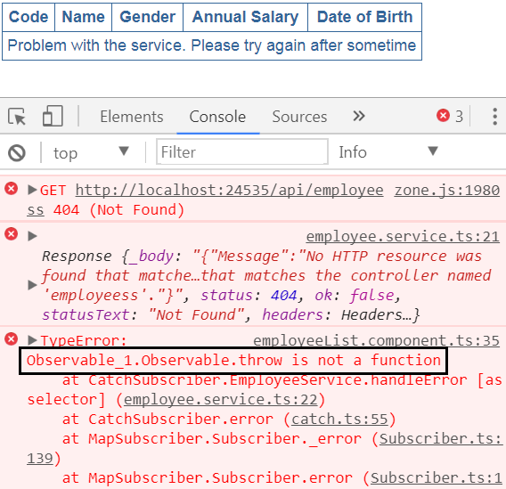   
  
If you uncomment the import statement in employee.service.ts file, then we see the error message we expect.

### Using Bootstrap with Angular 2

**Suggested Videos**  
[Part 26 - Angular and ASP.NET Web API](https://www.youtube.com/watch?v=FQ__z26TsHU) | [Text](http://csharp-video-tutorials.blogspot.com/2017/08/angular-and-aspnet-web-api.html) | [Slides](http://csharp-video-tutorials.blogspot.com/2017/08/angular-and-aspnet-web-api_7.html)  
[Part 27 - Angular 2 http service tutorial](https://www.youtube.com/watch?v=DETRfgZGuk8) | [Text](http://csharp-video-tutorials.blogspot.com/2017/08/angular-2-http-service-tutorial.html) | [Slides](http://csharp-video-tutorials.blogspot.com/2017/08/angular-2-http-service-tutorial_8.html)   
[Part 28 - Angular 2 http error handling](https://www.youtube.com/watch?v=gJKuil24Jag) | [Text](http://csharp-video-tutorials.blogspot.com/2017/08/angular-2-http-error-handling.html) | [Slides](http://csharp-video-tutorials.blogspot.com/2017/08/angular-2-http-error-handling_9.html)  
  
**In this video we will discuss**  
1. How to install and use Bootstrap with Angular  
2. How to enable intellisense for bootstrap  in Visual Studio

**How to install and use Bootstrap with Angular :** There are several ways to install Bootstrap. One way is by using Node.js command prompt.

**Step 1 :** Open node.js command prompt window. (Click windows start button, expand Node.js folder and right click on "node.js command prompt" and select "Run as administrator" from the command prompt)   
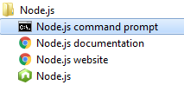   
  
**Step 2 :** In the command prompt navigate to the folder that contains your angular project and type the following command and press enter key. As Bootstrap has a dependency on jQuery, we are installing jQuery as well.  
npm install bootstrap@3 jquery --save   
npm command to install bootstrap   
  
This installs both Bootstrap and jQuery for use with our Angular project. Notice from the screenshot below, Bootstrap version 3.3.7 and jQuery version 3.2.1 are installed.   
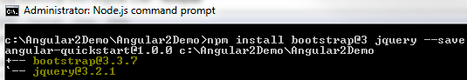   
  
The required Bootstrap and jQuery files are copied into the **node_modules** folder within the project directory.   
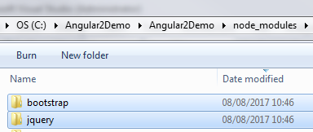   
  
Also, notice package.json file is also automatically updated with both the dependencies (Bootstrap and jQuery)   
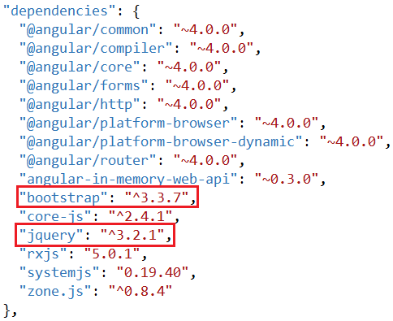   
  
**Step 3 :** Finally in index.html file add the following script and link elements to reference the required CSS and JS files. As you can see, these files are being served from the node_modules folder. 

<script src="/node_modules/jquery/dist/jquery.min.js"></script>

<link href="/node_modules/bootstrap/dist/css/bootstrap.min.css" rel="stylesheet" />

<script src="/node_modules/bootstrap/dist/js/bootstrap.min.js"></script>

The problem at the moment is intellisense for Bootstrap CSS classes is not working in index.html, or any of the components html or stylesheet files.   
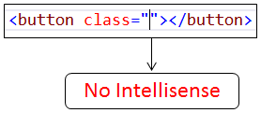   
  
**How to enable intellisense for bootstrap in Visual Studio :** Use the following workaround to enable intellisense for bootstrap in Visual Studio.  
**Step 1 :** In Visual Studio, click to select the Angular project and then click on "Show All Files" icon. You will then see "node_modules" folder.   
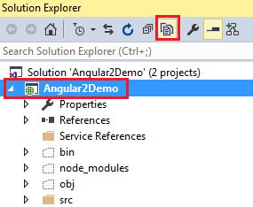   
  
**Step 2 :** Expand **"node_modules"** folder. Locate **"bootstrap"** folder. Right click on it and select **"Include In Project"** option from the context menu.   
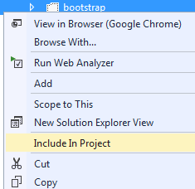   
  
At this point you should get bootstrap intellisense in index.html and all angular component html files. If you still do not get bootstrap intellisense, please restart Visual Stduio and you will get intellisense.   
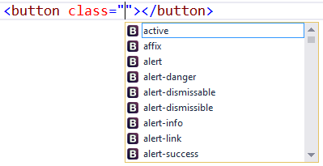   
  
As I said before, there are several ways to install bootstrap. One way is by using Node.js command prompt. The other way is by using Visual Stduio NuGet package manager. To install Bootstrap using NuGet package manager follow these steps.   
  
**Step 1 :**In Visual Studio Solution Explorer, right click on the Angular project and select "Manage NuGet Packages" option from the context menu   
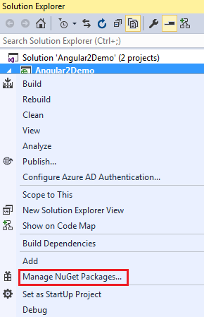   
  
**Step 2 :** In the "NuGet Package Manager" window

1. Click on the "Browse" link
2. In the textbox, type "Bootstrap" and press "enter" key
3. Click on the first item which says - Bootstrap
4. Click on the arrow pointing downwards to install

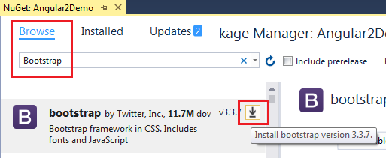   
  
The required CSS and JS files are placed in Content and Script folders. Finally place the required CSS and JS files in index.html page to start using Bootstrap. If you install Bootstrap using NuGet you don't have to do anything else to get bootstrap intellisense.   
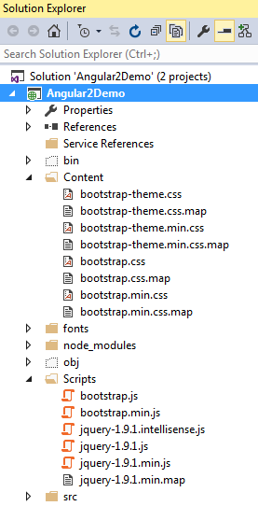   
  
If you do not want to download bootstrap, you can use their CDN links. You can find the official Bootstrap CDN links at the following page.  
<http://getbootstrap.com/getting-started/>  
  
Besides these 3 ways, there are other ways of installing Bootstrap. Which way to use depends on your project needs.

### Angular 2 routing tutorial

**Suggested Videos**  
[Part 27 - Angular 2 http service tutorial](https://www.youtube.com/watch?v=DETRfgZGuk8) | [Text](http://csharp-video-tutorials.blogspot.com/2017/08/angular-2-http-service-tutorial.html) | [Slides](http://csharp-video-tutorials.blogspot.com/2017/08/angular-2-http-service-tutorial_8.html)  
[Part 28 - Angular 2 http error handling](https://www.youtube.com/watch?v=gJKuil24Jag) | [Text](http://csharp-video-tutorials.blogspot.com/2017/08/angular-2-http-error-handling.html) | [Slides](http://csharp-video-tutorials.blogspot.com/2017/08/angular-2-http-error-handling_9.html)   
[Part 29 - Using Bootstrap with Angular 2](https://www.youtube.com/watch?v=OrH90MiFthM) | [Text](http://csharp-video-tutorials.blogspot.com/2017/08/using-bootstrap-with-angular-2.html) | [Slides](http://csharp-video-tutorials.blogspot.com/2017/08/using-bootstrap-with-angular-2_14.html)  
  
In this video we will discuss the basics of **routing in Angular 2**. Routing allows users to navigate from one view to another view.   
  
At the moment, we have EmployeeListComponent in our application. Let's create another simple HomeComponent so we can see how to navigate from HomeComponent to EmployeeListComponent and vice-versa

**Creating HomeComponent**  
1. Right click on the "app" folder and add a new folder. Name it "home". Right click on the "home" folder and add a new TypeScript file. Name it **home.component.ts**. Copy and paste the following code in it. Notice we have not included the 'selector' property in the @component decorator. The selector is only required if we are going to embed this component inside another component using the selector as a directive. Instead we are going to use the router to navigate to this component.

import { Component } from '@angular/core';

@Component({

    template: '<h1>This is the home page</h1>'

})

export class HomeComponent {

}

**2.** In the application root module (app.module.ts) import HomeComponent and include it in the declarations array of @NgModule decorator.   
  
import { HomeComponent } from './home/home.component';

@NgModule({

    imports: [BrowserModule, FormsModule, HttpModule],

    declarations: [AppComponent, HomeComponent, ...],

    bootstrap: [AppComponent]

})

export class AppModule { }

If the user tries to navigate to a route that does not exist, we want to route the user to PageNotFoundComponent. So let's create this component as well.   
  
Right click on the "others" folder and add a new TypeScript file. Name it pageNotFound.component.ts. Copy and paste the following code in it. 

import { Component } from '@angular/core';

@Component({

    template: '<h1>The page you are looking for does not exist</h1>'

})

export class PageNotFoundComponent {

}

Next, in the application root module (app.module.ts) import PageNotFoundComponent and include it in the declarations array of @NgModule decorator. 

import { PageNotFoundComponent } from './Others/pageNotFound.component';

@NgModule({

    imports: [BrowserModule, FormsModule, HttpModule],

    declarations: [AppComponent, PageNotFoundComponent, ...],

    bootstrap: [AppComponent]

})

export class AppModule { }

Here are the steps to implement routing in Angular 2 applications.   
  
**Step 1 :** Set <base href> in the application host page which is index.html. The <base href> tells the angular router how to compose navigation URLs. 

<base href="/src/">

**Step 2 :** In our angular application root module (app.module.ts), import RouterModule and Routes array and define routes as shown below. 

import { RouterModule, Routes } from '@angular/router';

// Routes is an array of Route objects

// Each route maps a URL path to a component

// The 3rd route specifies the route to redirect to if the path

// is empty. In our case we are redirecting to /home

// The 4th route (**) is the wildcard route. This route is used

// if the requested URL doesn't match any other routes already defined

const appRoutes: Routes = [

    { path: 'home', component: HomeComponent },

    { path: 'employees', component: EmployeeListComponent },

    { path: '', redirectTo: '/home', pathMatch: 'full' },

    { path: '**', component: PageNotFoundComponent }

];

// To let the router know about the routes defined above,

// pass "appRoutes" constant to forRoot(appRoutes) method

@NgModule({

    imports: [

        BrowserModule, FormsModule, HttpModule,

        RouterModule.forRoot(appRoutes)

    ],

    declarations: [AppComponent, HomeComponent, …],

    bootstrap: [AppComponent]

})

export class AppModule { }

**Important:** The order of the routes is very important. When matching routes, Angular router uses first-match wins strategy. So more specific routes should be placed above less specific routes. In the configuration above, routes with a static path are listed first, followed by an empty path route, that matches the default route. The wildcard route comes last because it matches every URL and should be selected only if no other routes are matched first.   
  
**Step 3 :** Tie the routes to application menu. Modify the root component (app.component.ts) as shown below. The only change we made is in the inline template.

* We are using Bootstrap nav component to create the menu. We discussed Bootstrap nav component in Part 27 of Bootstrap tutorial.
* The routerLink directive tells the router where to navigate when the user clicks the link.
* The routerLinkActive directive is used to add the active bootstrap class to the HTML navigation element whose route matches the active route.
* The router-outlet directive is used to specify the location where we want the routed component's view template to be displayed.
* The routerLink, routerLinkActive and router-outlet directives are provided by the RouterModule which we have imported in our application root module.
* If you forget to specify the router-outlet directive, you will get and error stating - cannot find primary outlet to load component.

import { Component } from '@angular/core';

@Component({

    selector: 'my-app',

    template: `

                    <div style="padding:5px">

                        <ul class="nav nav-tabs">

                            <li routerLinkActive="active">

                                <a routerLink="home">Home</a>

                            </li>

                            <li routerLinkActive="active">

                                <a routerLink="employees">Employees</a>

                            </li>

                        </ul>

                        <br/>

                        <router-outlet></router-outlet>

                    </div>

              `

})

export class AppComponent {

}

**Step 4 :** Finally in web.config file of our angular application include the following url-rewrite rule to tell IIS how to handle routes. The match url, <match url=".*" />, will rewrite every request. The URL in <action type="Rewrite" url="/src/"/> should match the base href in index.html. 

<system.webServer>

  <rewrite>

    <rules>

      <rule name="Angular Routes" stopProcessing="true">

        <match url=".*" />

        <conditions logicalGrouping="MatchAll">

          <add input="{REQUEST_FILENAME}" matchType="IsFile" negate="true" />

          <add input="{REQUEST_FILENAME}" matchType="IsDirectory" negate="true" />

        </conditions>

        <action type="Rewrite" url="/src/" />

      </rule>

    </rules>

  </rewrite>

</system.webServer>

If you do not have the above url rewrite rule, when you referesh the page you will 404 page not found error.   
  
To use "hash style" urls instead of HTML5 style url's, you just need to make one change in app.module.ts file. Set useHash property to true and pass it to the forRoot() method as shown below.  
  
RouterModule.forRoot(appRoutes, { useHash: true })  
  
If you are using "hash style" routes, we don't need the URL rewrite rule in web.config file.

### Angular 2 route parameters

**Suggested Videos**  
[Part 28 - Angular 2 http error handling](https://www.youtube.com/watch?v=gJKuil24Jag) | [Text](http://csharp-video-tutorials.blogspot.com/2017/08/angular-2-http-error-handling.html) | [Slides](http://csharp-video-tutorials.blogspot.com/2017/08/angular-2-http-error-handling_9.html)  
[Part 29 - Using Bootstrap with Angular 2](https://www.youtube.com/watch?v=OrH90MiFthM) | [Text](http://csharp-video-tutorials.blogspot.com/2017/08/using-bootstrap-with-angular-2.html) | [Slides](http://csharp-video-tutorials.blogspot.com/2017/08/using-bootstrap-with-angular-2_14.html)  
[Part 30 - Angular 2 routing tutorial](https://www.youtube.com/watch?v=L8TAn9OcdqU) | [Text](http://csharp-video-tutorials.blogspot.com/2017/08/angular-2-routing-tutorial.html) | [Slides](http://csharp-video-tutorials.blogspot.com/2017/08/angular-2-routing-tutorial_15.html)  
  
In this video we will discuss **passing parameters to routes in Angular**. This is continuation to [Part 30](https://www.youtube.com/watch?v=L8TAn9OcdqU). Please watch [Part 30](https://www.youtube.com/watch?v=L8TAn9OcdqU) from [Angular 2 tutorial](https://www.youtube.com/playlist?list=PL6n9fhu94yhWqGD8BuKuX-VTKqlNBj-m6) before proceeding.

Let us understand this with an example. We want to make Employee Code on Employee List component clickable.   
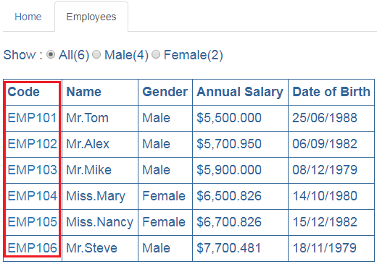   
  
  
  
When we click on an **Employee code**, we want to redirect the user to Employee Component which displays that specific employee details. In the URL we will pass the emploee code as a parameter. So clicking on **EMP101** will redirect the user to URL (http://localhost/employees/emp101). The Employee component will then read the parameter value from the URL and retrieves that specific employee details by calling the server side web service.   
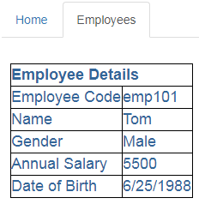   
  
In our previous video we have modified the code in **app.module.ts** file to use hash style routing. Let's remove useHash property, so we are using HTML5 style routing instead of hash style routing. Notice from the forRoot() method I have removed useHash property.  
RouterModule.forRoot(appRoutes)   
  
For HTML5 routing to work correctly, uncomment the following URL rewrite rule in web.config file of our Angular application.

<system.webServer>

  <rewrite>

    <rules>

      <rule name="Angular Routes" stopProcessing="true">

        <match url=".*" />

        <conditions logicalGrouping="MatchAll">

          <add input="{REQUEST_FILENAME}" matchType="IsFile" negate="true" />

          <add input="{REQUEST_FILENAME}" matchType="IsDirectory" negate="true" />

        </conditions>

        <action type="Rewrite" url="/src/" />

      </rule>

    </rules>

  </rewrite>

</system.webServer>

In the root application module (app.module.ts), include the following route. When the user navigates to a URL like (http://localhost:12345/employees/EMP101), we want to display EmployeeComponent. Notice the code parameter specified using colon (:).

{ path: 'employees/:code', component: EmployeeComponent }

Include the above route in appRoutes collection in app.module.ts file as shown below. Remember the order of the routes matter. 

const appRoutes: Routes = [

    { path: 'home', component: HomeComponent },

    { path: 'employees', component: EmployeeListComponent },

    { path: 'employees/:code', component: EmployeeComponent },

    { path: '', redirectTo: '/home', pathMatch: 'full' },

    { path: '**', component: PageNotFoundComponent }

];

Next, in EmployeeListComponent, modify the <td> element that displays employee code to bind it to the route we created above using the routerLink directive as shown below.  

<td>

    <a [routerLink]="['/employees',employee.code]">

        {{employee.code | uppercase}}

    </a>

</td>

**Explanation of the above code:**

* Notice in this example we are binding routerLink directive to an array.
* This array is called link parameters array.
* The first element in the array is the path of the route to the destination component.
* The second element in the array is the route parameter, in our case the employee code.

In the Angular EmployeeService (employee.service.ts), introduce the following getEmployeeByCode() method. 

getEmployeeByCode(empCode: string): Observable<IEmployee> {

    return this._http.get("http://localhost:31324/api/employees/" + empCode)

        .map((response: Response) => <IEmployee>response.json())

        .catch(this.handleError);

}

**Explanation of the above code:**

* This method takes employee code as a parameter and returns that employee object (IEmployee).
* This method issues a GET request to the Web API service.
* Once the Web API service returns the employee object, this method maps it to IEmployee type and returns it.

In one of our previous videos we have created EmployeeComponent to display employee details. When we created this component, we have hard coded employee data in the component itself. Now let's modify it

* To retrieve employee details by calling the Angular EmployeeService method **getEmployeeByCode()** we created above.
* This method calls the server side Web API service which retrieves that specific employee details from the database.
* The employee code parameter is in the URL
* To retrieve the parameter from the URL we are using the ActivatedRoute service provided by Angular
* Since ActivatedRoute is provided as a service inject it into the constructor just like how we have injected EmployeeService

**employee.component.ts**

import { Component, OnInit } from '@angular/core';

import { IEmployee } from './employee';

import { EmployeeService } from './employee.service';

import { ActivatedRoute } from '@angular/router';

@Component({

    selector: 'my-employee',

    templateUrl: 'app/employee/employee.component.html',

    styleUrls: ['app/employee/employee.component.css']

})

export class EmployeeComponent implements OnInit {

    employee: IEmployee;

    statusMessage: string = 'Loading data. Please wait...';

    constructor(private _employeeService: EmployeeService,

        private _activatedRoute: ActivatedRoute) { }

    ngOnInit() {

        let empCode: string = this._activatedRoute.snapshot.params['code'];

        this._employeeService.getEmployeeByCode(empCode)

            .subscribe((employeeData) => {

                if (employeeData == null) {

                    this.statusMessage =

                        'Employee with the specified Employee Code does not exist';

                }

                else {

                    this.employee = employeeData;

                }

            },

            (error) => {

                this.statusMessage =

                    'Problem with the service. Please try again after sometime';

                console.error(error);

            });

    }

}

**employee.component.html** 

<table *ngIf="employee">

    <thead>

        <tr>

            <th colspan="2">

                Employee Details

            </th>

        </tr>

    </thead>

    <tbody>

        <tr>

            <td>Employee Code</td>

            <td>{{employee.code}}</td>

        </tr>

        <tr>

            <td>Name</td>

            <td>{{employee.name}}</td>

        </tr>

        <tr>

            <td>Gender</td>

            <td>{{employee.gender}}</td>

        </tr>

        <tr>

            <td>Annual Salary</td>

            <td>{{employee.annualSalary}}</td>

        </tr>

        <tr>

            <td>Date of Birth</td>

            <td>{{employee.dateOfBirth}}</td>

        </tr>

    </tbody>

</table>

<div *ngIf="!employee">

    {{statusMessage}}

</div>

There are different approaches to retrieve route parameters values. We will discuss all the different approaches and when to use what in our upcoming videos.  
  
Since we need EmployeeService both in EmployeeListComponent and EmployeeComponent, let's register it in the root module so we get a singleton instead of multiple instances of the service.    
  
We will discuss what is a Singleton in Angular and why is it important in our next video. For now, let's remove the EmployeeService registration from EmployeeListComponent by removing the following providers property in employeeList.component.ts file   
  
providers: [EmployeeService]  
  
Now regsiter the EmployeeService in application root module (app.module.ts) by including it in the providers property of @NgModule decorator as shown below  
  
@NgModule({  
    imports: [  
        BrowserModule,  
        OtherSystemModules..  
    ],  
    declarations: [  
        AppComponent,  
        OtherComponents..  
    ],  
    bootstrap: [AppComponent],  
    providers: [EmployeeService]  
})  
export class AppModule { }

### Angular dependency injection

**Suggested Videos**  
[Part 29 - Using Bootstrap with Angular 2](https://www.youtube.com/watch?v=OrH90MiFthM) | [Text](http://csharp-video-tutorials.blogspot.com/2017/08/using-bootstrap-with-angular-2.html) | [Slides](http://csharp-video-tutorials.blogspot.com/2017/08/using-bootstrap-with-angular-2_14.html)  
[Part 30 - Angular 2 routing tutorial](https://www.youtube.com/watch?v=L8TAn9OcdqU) | [Text](http://csharp-video-tutorials.blogspot.com/2017/08/angular-2-routing-tutorial.html) | [Slides](http://csharp-video-tutorials.blogspot.com/2017/08/angular-2-routing-tutorial_15.html)   
[Part 31 - Angular 2 route parameters](https://www.youtube.com/watch?v=z47aJGe7jR4) | [Text](http://csharp-video-tutorials.blogspot.com/2017/08/angular-2-route-parameters.html) | [Slides](http://csharp-video-tutorials.blogspot.com/2017/08/angular-2-route-parameters_16.html)  
  
**In this video we will discuss**  
1. What is Dependency Injection  
2. How dependency injection works in angular

Let us understand Dependency Injection in Angular with an example. Consider this piece of code in EmployeeListComponent.

export class EmployeeListComponent implements OnInit {

    private _employeeService: EmployeeService;

    constructor(_employeeService: EmployeeService) {

        this._employeeService = _employeeService;

    }

    ngOnInit() {

        this._employeeService.getEmployees()

            .subscribe(

            employeesData => this.employees = employeesData,

            error => this.statusMessage = 'Error');

    }

    // Rest of the code

}

1. In EmployeeListComponent we need an instance of EmployeeService, so we could use that instance to call getEmployees() method of the service which retrieves the list of employees which this component needs.
2. But if you look at this code, the EmployeeListComponent is not creating an instance of EmployeeService.
3. We declared a private field _employeeService of type EmployeeService. The constructor also has a parameter _employeeService of type EmployeeService. The constructor is then initializing the private class field _employeeService with it's parameter.
4. We are then using this private field _employeeService to call the service method getEmployees()
5. The obvious question that we get at this point is how are we getting an instance of the EmployeeService class.
6. We know for sure the EmployeeListComponent is not creating the instance of the EmployeeService class.
7. From looking at the code we can understand that the constructor is provided with an instance of EmployeeService class, and then the constructor is assigning that instance to the private field _employeeService.
8. At this point, the next question that comes to our mind is who is creating and providing the instance to the constructor.
9. The answer to this question is the Angular Injector. When an instance of EmployeeListComponent is created, the angular injector creates an instance of the EmployeeService class and provides it to the EmployeeListComponentconstructor. The constructor then assigns that instance to the private field _employeeService. We then use this private field _employeeService to call the EmployeeService method getEmployees().
10. Another question that comes to our mind is - How does the angular injector knows about EmployeeService.
11. For the Angular injector to be able to create and provide an instance of EmployeeService, we will have to first register the EmployeeService with the Angular Injector. We register a service with the angular injector by using the providers property of @Component decorator or @NgModule decorator.
12. We already know we decorate an angular component with @Component decorator and an angular module with @NgModule decorator. So this means if we are registering a service using the providers property of the @Component decorator then we are registering the service with an angular injector at the component level. The service is then available to that component and all of it's children.
13. On the other hand if we register the service using the providers property of the @NgModule decorator then we are registering the service with an angular injector at the module level which is the root injector. The service registered with the root injector is then available to all the component accross the entire application.
14. We will discuss these hierarchical injectors in Angular in detail with an example in our upcoming videos.

**Now let's quickly recap what we have discussed so far**

* We register a service with the angular injector by using the providersproperty of @Component decorator or @NgModule decorator.
* When a component in Angular needs a service instance, it does not explicitly create it. Instead it just specifies it has a dependency on a service and needs an instance of it by including the service as a constructor parameter.
* When an instance of the component is created, the angular injector creates an instance of the service class and provides it to component constructor.
* So the component which is dependent on a service instance, receives the instance from an external source rather than creating it itself. This is called Dependency Injection.

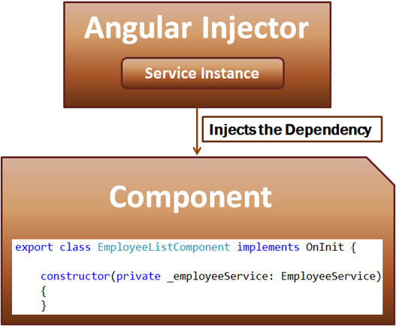   
  
**What is Dependency Injection**  
It's a coding pattern in which a class receives its dependencies from an external source rather than creating them itself.    
  
So if we relate this definition to our example, EmployeeListComponent has a dependency on EmployeeService. The EmployeeListComponent receives the dependency instance (i.e EmployeeService instance) from the the external source (i.e the angular injector) rather than creating the instance itself.

1. Why should we use Dependency Injection?
2. What benefits it provide?
3. Why can't we explicitly create an instance of the EmployeeService class using the new keyword and use that instance instead in our EmployeeListComponent?

We will answer these questions in our next video.

### Why dependency injection

**Suggested Videos**  
[Part 30 - Angular 2 routing tutorial](https://www.youtube.com/watch?v=L8TAn9OcdqU) | [Text](http://csharp-video-tutorials.blogspot.com/2017/08/angular-2-routing-tutorial.html) | [Slides](http://csharp-video-tutorials.blogspot.com/2017/08/angular-2-routing-tutorial_15.html)  
[Part 31 - Angular 2 route parameters](https://www.youtube.com/watch?v=z47aJGe7jR4) | [Text](http://csharp-video-tutorials.blogspot.com/2017/08/angular-2-route-parameters.html) | [Slides](http://csharp-video-tutorials.blogspot.com/2017/08/angular-2-route-parameters_16.html)   
[Part 32 - Angular dependency injection](https://www.youtube.com/watch?v=jWODteEGQmw) | [Text](http://csharp-video-tutorials.blogspot.com/2017/08/angular-dependency-injection.html) | [Slides](http://csharp-video-tutorials.blogspot.com/2017/08/angular-dependency-injection_22.html)  
  
In this video we will discuss **why should we use dependency injection and the benefits it provide**. Let us understand this with a very simple example.

Let us say we want to build a Computer. In reality to build a computer we need several objects like processor, ram, hard-disk drive etc. To keep this example simple let's say we just need a processor object to build a computer.

Our Computer and Processor classes are as shown below. Notice at the moment, we are not using dependency injection. To build a Computer we need a Processor object and the Computer class is creating an instance of the Processor class it needs. This is the kind of programming style that most of us are used to and it is easy to understand as well. But there are 3 fundamental problems with this code

1. This code is difficult to maintain over time
2. Instances of dependencies created by a class that needs those dependencies are local to the class and cannot share data and logic.
3. Hard to unit test

export class Computer {

    private processor: Processor;

    constructor() {

        this.processor = new Processor();

    }

}

export class Processor {

    constructor() {

    }

}

Now let us understand why this code is difficult to maintain. Let us say, the Processorclass needs to know the speed of the processor to be able to create an instance of it. One way to address this requirement is by passing the processor speed as a parameter to the constructor of the Processor class as shown below. 

export class Processor {

    constructor(speed: number) {

    }

}

This change in the Processor class breaks the Computer class. So every time the Processor class changes, the Computer class also needs to be changed. At the moment, the Computer class has only one dependency. In reality it may have many dependencies and those dependencies in turn may have other dependencies. So when any of these dependencies change, the Computer class may also need to be changed. Hence this code is difficult to maintain.  
  
The reason we have this problem is because the Computer class itself is creating the instance of the Processor class. Instead if an external source can create the processor instance and provide it to the computer class, then this problem can be very easily solved and that's exactly what dependency injection does. I have rewritten the above code using dependency injection, DI for short as shown below.

export class Computer {

    private processor: Processor;

    constructor(processor: Processor) {

        this.processor = processor;

    }

}

export class Processor {

    constructor(speed: number) {

    }

}

Notice with DI, the Computer class is not creating the instance of the Processor class itself. Instead we have specified that the Computer class has a dependency on Processor class using the constructor. Now, when we create an instance of the Computer class, an external source i.e the Angular Injector will provide the instance of the Processor class to the Computer class. Since now the the Angular injector is creating the dependency instance, the Computer class need not change when the Processor class changes.  
  
Now, let us understand the second problem - Instances of dependencies created by a class that needs those dependencies are local to the class and cannot share data and logic. The Processor class instance created in the Computer class is local to the Computer class and cannot be shared. Sharing a processor instance does not make that much sense, so let's understand this with another example.   
  
Let us say we have a service called UserPreferencesService which keeps track of the user preferences like colour, font-size etc. We want this data to be shared with all the other components in our application. Now if we create an instance of this UserPreferenceService class in every component class like we did in the Computerclass, the service instance is local to the component in which we have created it and the data cannot be shared with other components. So if we need this UserPreferencesService in 10 different components, we end up creating 10 instances of the service, one for each component. As the service instance is local to the component that has created it, the data that local service instance has cannot be shared by other components. If this does not make sense at the moment, please do not worry, we will discuss it with a working example in our next video.  
  
On the other hand if we use Dependency Injection (DI), the angular injector provides a Singleton i.e a single instance of the service so the data and logic can be shared very easily across all the components.  
  
From unit testing standpoint, it is difficult to mock the processor object, so unit testing Computer class can get complex. In this example, the Computer class has just one dependency (i.e the dependency on the Processor object).   
  
In a real world application, a given object may have a dependency on several other objects, and those dependencies inturn may have dependencies on other objects. Just imagine, how complicated unit testing can become with all these hierarchies of dependencies if we do not have the ability to mock the dependencies.  
  
With Dependency Injection it is very easy to mock objects when unit testing. This is one of the greatest benefits of DI.  
  
If you are new to unit testing and mocking, it may be difficult for you to understand why unit testing can get difficult and complicated if we do not have the ability to mock dependencies. In our upcoming videos we will discuss unit testing and mocking and it should be much clear at that point.  
  
**So in summary DI provides these benefits**

1. Create applications that are easy to write and maintain over time as the application evolves
2. Easy to share data and functionality as the angular injector provides a Singleton i.e a single instance of the service
3. Easy to write and maintain unit tests as the dependencies can be mocked

### Promises in angular 2 example

**Suggested Videos**  
[Part 35 - Angular Injector](https://www.youtube.com/watch?v=dH1EWRoEcMo) | [Text](http://csharp-video-tutorials.blogspot.com/2017/08/angular-injector.html) | [Slides](http://csharp-video-tutorials.blogspot.com/2017/08/angular-injector_28.html)  
[Part 36 - Angular root injector](https://www.youtube.com/watch?v=qy-0yD7hDVA) | [Text](http://csharp-video-tutorials.blogspot.com/2017/08/angular-root-injector.html) | [Slides](http://csharp-video-tutorials.blogspot.com/2017/08/angular-root-injector_29.html)   
[Part 37 - Angular router navigate method](https://www.youtube.com/watch?v=PoRmZWd6xYE) | [Text](http://csharp-video-tutorials.blogspot.com/2017/08/angular-router-navigate-method.html) | [Slides](http://csharp-video-tutorials.blogspot.com/2017/08/angular-router-navigate-method_30.html)   
  
In this video we will discuss **using Promises instead of Observables in Angular**.